Inherited vs Self-Made Wealth:
Theory & Evidence from a Rentier Society

Thomas Piketty, Gilles Postel-Vinay & Jean-Laurent Rosenthal*

This version: April 14, 2010**

Abstract: This paper divides the population into two groups: the “inheritors” or “rentiers” (whose wealth is smaller than the capitalized value of their inherited wealth, i.e. who consumed more than their labor income during their lifetime); and the “savers” or “self-made men” (whose wealth is larger than the capitalized value of their inherited wealth, i.e. who consumed less than their labor income). Applying this simple theoretical model to a unique micro data set on inheritance and matrimonial property regimes, we find that Paris in 1872-1937 looks like a prototype “rentier society”. Rentiers made about 10% of the population of Parisians but owned 70% of aggregate wealth. Rentier societies thrive when the rate of return on private wealth r is permanently and substantially larger than the growth rate g. This was the case in the 19th century and early 20th century and is likely to happen again in the 21st century. In such cases top successors, by consuming part of the return to their inherited wealth, can sustain living standards far beyond what labor income alone would permit.

* Piketty and Postel-Vinay: Paris School of Economics (PSE). Rosenthal: California Institute of Technology (Catech).

* This preliminary version probably contains a number of typos and omissions. All comments are welcome (piketty@ens.fr, gpv@ens.fr, jlr@hss.caltech.edu). A detailed data appendix supplementing the present working paper is available on-line at www.jourdan.ens.fr/piketty/rentiersociety/.
1. Introduction

The relative importance of inherited and self-made wealth is arguably one of the most controversial issues in political debates and in the social sciences. Of course, most countries like to view themselves as fundamentally meritocratic. That is, as societies where the path to material well being and wealth involves hard work and wise savings decisions – rather than inheritance. France is no exception. Ever since the revolution of 1789, the French like to view themselves as citizens of a country where the principles of individual merit, personal accountability, and freedom have triumphed over the principle of lineage. Equally strong beliefs exist in many parts of the world, most notably in the United States. To be honest, however, these are mostly self-serving political statements rather than facts – in France, in the United States, and elsewhere. In terms of scientific research, we actually know very little about the relative importance of inherited wealth and self-made wealth, and how and why it evolves over time and across countries.

This paper makes two contributions to this debate. First, we propose a new theoretical definition of the share of inherited wealth in aggregate wealth. We begin with a population observed at a given point in time. We divide that population into two groups: first, the “inheritors” or “rentiers”. Their wealth is less than the capitalized value of their inherited wealth (they have consumed more than their labor income by that time). Henceforth we will use rentier and inheritor interchangeably. The second group is composed of “savers.” Their wealth is larger than the capitalized value of their inherited wealth (they have consumed less than their labor income). We define inherited wealth as the sum of inheritors’ wealth plus the inherited fraction of savers’ wealth, and self-made wealth as the non-inherited fraction of savers’ wealth. By construction, the shares of inherited and self-made wealth in aggregate wealth sum to 100%. Although the definition is fairly straightforward, it differs considerably from the standard ones based upon representative agent models. We argue that our definition is conceptually more consistent, and more useful to analyze the structure of wealth accumulation processes.

Next, in order to illustrate this point, we apply our theoretical definitions to an extraordinarily rich micro level data base on inheritance and matrimonial property regimes, which we collected using individual estate tax records in Paris between 1872 and 1937. We find that inheritors made up about 10% of Parisians and owned about 60%-70% of the wealth. The total fraction of inherited wealth was even larger (between 70% and 80%). Most importantly, rentiers’ share of population and wealth rises dramatically with wealth levels. Inheritors made only 25% of the middle class (wealth fractile P50-90), but about 50% of the “middle rich” (P90-99), and over 70% of the “very rich” (P99-100). This does not mean that there were no self-made entrepreneurs. About a quarter of the very rich where individuals who had started off in life with limited inherited wealth and made their way to the top. But they were a minority.

We argue that Paris between 1872 and 1937 was the quintessence of what one might indeed call a “rentier society”. That is, a society where top successors could sustain living standards far beyond what labor income and individual merit alone would have permitted. They did so by drawing heavily on the return to their inherited wealth. In sum, France at that time looked more like a “land of rentiers” than a “land of opportunities”.

What do we learn from these findings? Do rentier societies belong to the past, or are today’s developed societies not that different, and why? Unfortunately, we do not know of any sufficiently rich data set for the contemporary period (neither for France nor for any country we know) that to undertake the same rigorous computations as we perform for Paris 1872-1937. To our knowledge, the simple decomposition between inheritors and savers has never been estimated for any population prior to the present paper. However, exploratory computations suggest that while today’s rentiers shares in population and wealth are probably lower than in Paris 1872-1937, they might not that much lower. Rich societies must have lots of inheritors.

First, when studying wealth and inheritance, one must bear in mind that the historical decline of wealth concentration in developed societies has been quantitatively less important than some observers tend to imagine. In order to fix ideas, we compare on Table 1 the wealth distributions prevailing in Paris and France in 1912 and in today’s United States. The Paris 1912 data comes from our data set. The French Data comes from published reports of estate tax filings. The U.S. 2007 data simply comes from the latest SCF (Survey of consumer finances), with no adjustment whatsoever. In particular, the SCF probably understates top wealth shares, and we did not try to correct for this. The Paris 1912 data is probably closer to the true distribution prevailing then. The data are derived from estate tax filings at a time when tax rates were extremely low and heirs had strong incentives to report the entirety of decedent’s estate. In order to make the figures more concrete and comparable, we report on Table 1 both the wealth shares and the corresponding average wealth levels, resetting all the distributions to the mean wealth in Paris in 1912 (136.000 francs).

Insert Table 1: Wealth inequality: Paris 1912 vs U.S. 2007

Paris in 1912 was clearly a very unequal place. The top 10% of the population, which one might call the “upper class” owned over 95% of aggregate wealth (with 60%-65% for the top 1%, and 30%-35% for the next 9%). The wealth shares of the bottom 50% (the “poor”) and the middle 40% (the “middle class”) were close to 0%. Basically there was no middle class. This is consistent with our previous research, showing that wealth concentration reached all time peak on the eve of World War 1 (with the richest 1% owning more than half of the wealth in France and over 60% in Paris), and then declined in the aftermath of the world wars (particularly World War 2). Now, if one compares with the level of wealth concentration observed in today’s United States, one can see that the main transformation of the past century is the development of a middle class. In today’s U.S., in the same way as in today’s France and other rich countries, the middle class is made of individuals who may not own a lot individually (typically, 100,000€ or 200,000€), but who are very numerous and therefore own collectively a non-negligible fraction of aggregate wealth. This is certainly a major development, with far reaching political consequences. The simple point we want to make here is simply that one should not overstate the quantitative importance of these historical changes. At the end of the day, the middle class wealth share in today’s United States is only 26%; the upper class wealth share (as measured by the SCF) is 72%. This is certainly lower than the 96% observed in Paris 1912. But this is not that much lower. France in 1912 falls somewhere in between: more equal than Paris but more unequal than the US.

The first reason we feel that the study of the rentier societies of the past can be of some relevance for the study of the present and the future is the high quality of the data and the permanence of the processes that lead to wealth accumulation. While the economy of Paris between 1872 and 1937 is unique and radically different from in many ways from contemporary economy, the individual trade-off between consumption and savings remains the same. The wealth accumulation process always seems to involve large inequality and very different groups of agents and wealth trajectories. This simply cannot be properly understood and analyzed within representative agent frameworks.

The second reason why we believe that the issue of inherited wealth should rank highly on the research agenda is simply because aggregate inheritance is growing. In the coming decades, it is likely to become as large as it was in Paris between 1872 and 1937. In any case it will be much bigger than the unusually low levels observed in the 1950s-1970s period (a period which has had a deep – and arguably excessive – impact on modern economic thinking on wealth accumulation, with a great deal of faith in the lifecycle story). As one of us has recently shown for the case of France, the aggregate inheritance flow has gone through a very marked U-shaped evolution over the past century (see Figure 1, which we extract from Piketty (2010)). This aggregate evolution can be partly accounted for in part by the aggregate evolution of the private wealth-income ratio (which fell to unusually low levels in the 1950s, due to war destructions and – most importantly – to the low real estate and stock prices prevailing in the post war period). But this long run U-shaped pattern is also the consequence of the fact that it took long time for the age-wealth profile to become rising again, but it eventually did.

The key economic mechanism behind aggregate inheritance’s eventual return to its former high levels follows directly from a simple “r>g” logic. That is, when the rate of return on private wealth r is permanently and substantially larger than the growth rate g (say, r=4%-5% vs. g=1%-2%), which was the case in the 19th century and early 20th century and is likely to happen again in the 21st century, then past wealth and inheritance are bound to play a key role for aggregate wealth accumulation. As we shall see in the present paper, this “r>g” logic also has major consequences not only at the aggregate level, but also for the micro structure of lifetime inequality and the emergence and sustainability of rentier societies.

2. Relation to existing literature

TO BE COMPLETED

This research is related to several literatures.

Literature on long run trends in income and wealth inequality

Literature on intergenerational transfers and wealth accumulation

Literature on calibrated models of wealth distributions

3. A simple model of “inheritors” vs “savers”

3.1. Basic notations and definitions

Consider a population of size N_{t}, with aggregate private wealth W_{t} and national income Y_{t}=Y_{Lt}+r_{t}W_{t}, where Y_{Lt} is aggregate labor income, and r_{t} is the average rate of return on private wealth. We note w_{t}=W_{t}/N_{t} per capita wealth, y_{Lt}=Y_{Lt}/N_{t} per capita labor income, y_{t}=Y_{t}/N_{t}=y_{Lt}+r_{t}w_{t} per capita national income.

Consider a given individual i with wealth w_{ti} at time t. Assume he or she received bequest b_{ti}⁰ at time t_{i}<t. Note b_{ti}* = b_{ti}⁰ e^{r(ti,t)} the capitalized value of b_{ti}⁰ at time t (where r(t_{i},t) is the cumulated rate of return between time t_{i} and time t).

Definitions.
 | Inheritors (rentiers) | Savers (self-made men)
Number | N_{t}^{r} = {i s.t. w_{ti}<b_{ti}*} | N_{t}^{s} = {i s.t. w_{ti}≥b_{ti}*}.
Share in population | ρ_{t}=N_{t}^{r}/N_{t} | 1-ρ_{t}=N_{t}^{s}/N_{t}
Average wealth | w_{tr}=E(w_{ti} | w_{ti}<b_{ti}*) | w_{ts}=E(w_{ti} | w_{ti}≥b_{ti}*)
Average capitalized bequest | b_{tr}*=E(b_{ti}* | w_{ti}<b_{ti}*) | b_{ts}*=E(b_{ti}* | w_{ti}≥b_{ti}*)
Share in aggregate wealth | π_{t}=ρ_{t}w_{tr}/w_{t} | 1-π_{t}=(1-ρ_{t})w_{ts}/w_{t}

φ_{t} and 1-φ_{t} the shares of inherited wealth and self-made wealth in aggregate wealth:
φ_{t} = [ρ_{t}w_{tr} + (1-ρ_{t})b_{ts}*]/w_{t} = π_{t} + (1-ρ_{t})b_{ts}*/w_{t} (3.1)
1-φ_{t} = (1-ρ_{t})(w_{ts}-b_{ts}*)/w_{t} = 1-π_{t} - (1-ρ_{t})b_{ts}*/w_{t} (3.2)

It is worth stressing that the joint distribution G_{t}(w_{ti},b_{ti}*) of current wealth w_{ti} and capitalized bequest b_{ti}* is all we need in order to compute ρ_{t}, π_{t} and φ_{t}. This does require high-quality, individual-level data on wealth and inheritance. But the important point is that we do need to know anything about individual labor income and/or consumption paths (y_{Lt’i}, c_{t’i}, t’<t) followed by individual i during his lifetime. Of course it is always better to have more data. In case we can also observe (or estimate) labor income and consumption paths, then one can compute the lifetime individual savings rate s_{Bti}, i.e. the share of lifetime resources that was not consumed up to time t:

s_{Bti} = w_{ti}/(b_{ti}*+y_{Lti}*) = 1 - c_{ti}*/(b_{ti}*+y_{Lti}*) (3.3)

With: y_{Lti}* = ∫_{t’<t} y_{Lt’i} e^{r(t’,t)} dt’ = capitalized value at time t of past labor income flows
c_{ti}* = ∫_{t’<t} c_{t’i} e^{r(t’,t)} dt’ = capitalized value at time t of past consumption flows

By definition, inheritors are individuals who consumed more than their labor income (i.e. w_{ti}<b_{ti}* ↔ c_{ti}*>y_{Lti}*), while savers are individuals who consumed less than their labor income (i.e. w_{ti}≥b_{ti}* ↔ c_{ti}*≤y_{Lti}*). But the point is that we only need to observe w_{ti} and b_{ti}* in order to determine whether a given individual i is an inheritor or a saver.

In this paper, we want to estimate ρ_{t}, π_{t} and φ_{t} at the aggregate level. We also want to track how ρ_{t}(w), π_{t}(w) and φ_{t}(w) vary with the wealth level w. In other words we would like to know what is the fraction of inheritors ρ_{t}(w) within the top 10% or top 1% of the wealth distribution, and what wealth share π_{t}(w) do they own within top wealth fractiles?

Note also one can define ρ_{t}, π_{t} and φ_{t} either for the entire living population or for the subpopulation of decedents (i.e. for the subset of individuals i who die at time t). We will provide both computations (as well as the full age profiles ρ_{t}(a), π_{t}(a) and φ_{t}(a)), but we tend to be more interested in the values taken by ρ_{t}, π_{t} and φ_{t} among decedents. The very idea of lifetime balance sheets (how much did one receive in lifetime resources, vs how much did one consume) makes more sense at the time of death. At young age (say, a=20), very few people have received any bequest, so ρ_{t}(a), π_{t}(a) and φ_{t}(a) are bound to be close to 0%.

3.2. A simple numerical illustration

Example 1. At age a=60, Mr Martin owns a Paris apartment worth 500,000€ (net of outstanding mortgage liabilities), 100,000€ in equities, another 300,000€ in mutual funds. At age I=30, he inherited 400,000€ in life insurance assets from his parents, which he does not own any more. So w_{ti}=900,000€ and b_{ti}⁰=400,000€. With a constant rate of return r_{t}=r, capitalized bequest b_{ti}* is given by:

b_{ti}* = e^{r(a-I)} b_{i} (3.4)

With I=30, a=60 and r=4%, then e^{r(a-I)}=332% and b_{ti}*=1,328,000€ = 400,000€ (capital value) + 928,000€ (cumulated return). That is, b_{ti}*>w_{ti}, i.e. according to our definitions Mr Martin is an “inheritor” (or a “rentier”). We do not really care about how exactly Mr Martin organized his life and his finances, or how he used his 400,000€ inheritance. Maybe he invested this sum in equity and mutual funds shares, from which he received a cumulated income equal to 928,000€. He then used part of this to purchase his Paris apartment, and consumed the 428,000€ more (928,000€ - 500,000€) that remained. Maybe he decided to use the 400,000€ capital to purchase his Paris apartment right away (with a small mortgage of 100,000€), so as to save on rents. The details of his decisions are wholly irrelevant from a welfare perspective. Whatever his consumption and investment choices were, he acquired assets while at the same time consuming more than his labor income. Of course, the rate of return on assets plays a key role in these computations. With r=3%, e^{r(a-I)}=246% and b_{ti}*=984,000€. With r=5%, then e^{r(a-I)}=448% and b_{ti}*=1,792,000€. We return to this in the empirical section.

Example 2. At age a=60, Mr Smith owns a small house worth 60,000€ (net of outstanding mortgage liabilities), and 20,000€ in various savings accounts. He inherited 10,000€ from his parents at age I=30, which he spent when he contracted a loan to purchase his house. So w_{ti}=80,000€ and b_{i}=10,000€. With r=4%, e^{r(a-I)}=332% and b_{ti}*=33,000€. So we have b_{ti}*<w_{ti}. Mr Smith is a “saver”: over his lifetime he consumed less than his labor income.

Now consider a hypothetical economy where one fifth (ρ_{t}) the population are inheritors like Mr Martin (w_{tr}=900,000€, b_{tr}*=1,328,000€) and four fifths (1-ρ_{t}) are savers like Mr Smith (w_{ts}=80,000€, b_{ts}*=33,000€). Average wealth w_{t}=ρ_{t}w_{tr}+(1-ρ_{t})w_{ts}=244,000€, while average capitalized bequest b_{t}*=ρ_{t}b_{tr}*+(1-ρ_{t})b_{ts}*=292,000€. The inheritors’ share of aggregate wealth π_{t} is ρ_{t}w_{tr}/w_{t} =74%, and the total share of inherited wealth in aggregate wealth is φ_{t}=π_{t}+(1-ρ_{t})b_{ts}*/w_{t} =85%.

These numbers were chosen for illustration, but they are not too different from the actual numbers currently prevailing for the top 20% and the bottom 80% of the wealth distribution (each taken as a homogenous group) in countries like France or the United States.

3.3. Differences with the Kotlikoff-Summers-Modigliani definitions

The key difference between our definition of the inheritance share in aggregate wealth accumulation and the Kotlikoff&Summers-Modigliani (K&S-M) standard definitions is that we explicitly distinguish between two subgroups in the population, while the K&S-M definitions are based upon a representative agent model. Kotlikoff and Summers (1981, 1988) defined the inheritance share as the share of aggregate capitalized bequests in aggregate wealth:

φ_{t}^{KS} = B_{t}*/W_{t} = b_{t}*/w_{t} (3.5)

With: B_{t}* = capitalized value at time t of past bequests (i.e. all bequests received at any time t’<t by individuals still alive at time t)
b_{t}* = B_{t}*/N_{t} = per capita capitalized value at time t of past bequests

Modigliani (1986, 1988) defined the inheritance share as the share of aggregate non-capitalized bequests in aggregate wealth:

φ_{t}^{M} = B_{t}⁰/W_{t} = b_{t}⁰/w_{t} (3.5)

With: B_{t}⁰ = non-capitalized value of past bequests (i.e. all bequests received at any time t’<t by individuals still alive at time t)
b_{t}⁰ = B_{t}⁰/N_{t} = per capita non-capitalized value at time t of past bequests

By construction, as long as assets generate positive returns (r>0): φ_{t}^{M} < φ_{t}^{KS}.

Take for instance the illustrative economy described above. Applying Modigliani’s definition, we find φ_{t}^{M}=b_{t}⁰/w_{t}=36%. Applying Modigliani-Summers’ definition, we find φ_{t}^{KS}=b_{t}*/w_{t}=120%. With our own definition we found φ_{t}=85% (see above).

For plausible joint distributions G_{t}(w_{ti},b_{ti}*), our inheritance share φ_{t} will typically fall somewhere in the interval [φ_{t}^{M},φ_{t}^{KS}]. Note, however, that there is no theoretical reason why it should be so in general. Imagine for instance an economy where inheritors entirely consume their bequest the very day they receive it, and never save afterwards, so that wealth accumulation entirely comes from the savers, who never received any bequest (or negligible amounts), and who patiently accumulate savings from their labor income. Then with our definition φ_{t} =0%: in this economy, 100% of wealth accumulation comes from savings, and nothing at all comes from inheritance. However with the Modigliani and Kotlikoff-Summers definitions, the inheritance shares φ_{t}^{M} and φ_{t}^{KS} could be arbitrarily large.

More generally, the problem with the K&S-M representative-agent approach is that it fails to recognize that the wealth accumulation process always involves very different kind of people and wealth trajectories. In every economy, there are inheritors (people who typically consume part the return to their inherited wealth), and there are savers (people who do not inherit much but do accumulate wealth through labor income savings). This is an important feature of the real world that must be taken into account for a proper understanding of the aggregate wealth accumulation process.

The Modigliani definition is particularly problematic, since it simply fails to recognize that inherited wealth produces flow returns. This mechanically leads to artificially low numbers for the inheritance share φ_{t}^{M} (as low as 20%-40%), and to artificially high numbers for the life-cycle share in wealth accumulation, which Modigliani simply defined as 1-φ_{t}^{M} (up to 60%-80%). As Blinder (1988) argued: “a Rockefeller with zero lifetime labor income and consuming only part of his inherited wealth income would appear to be a life-cycle saver in Modigliani’s definition, which seems weird to me.” In the illustrative example described above, even if everybody in the economy was like Mr Martin (i.e. if all wealth comes from inheritance, so that φ_{t}=100% with our definition), then Modigliani would still find an inheritance share φ_{t}^{M} of only 44%, and would attribute 56% of aggregate wealth accumulation to life-cycle motives. This really makes little sense.

The Kotlikoff-Summers definition is conceptually more satisfactory than Modigliani’s. But it suffers from the opposite drawback, in the sense that it mechanically leads to artificially high numbers for the inheritance share φ_{t}^{KS}. As the above example illustrates, φ_{t}^{KS} can typically be larger than 100%, even though there are savers in the economy, and a significant fraction of aggregate wealth accumulation comes from them. This will arise whenever the cumulated return to inherited wealth consumed by inheritors exceeds the savers’ wealth accumulation from their labor savings. In the real world, this condition seems to hold not only in prototype rentier societies such as Paris 1872-1937, but also in countries and time periods when aggregate inheritance flow are relatively low. For instance, aggregate French series show that the capitalized bequest share φ_{t}^{KS} has been larger than 100% throughout the 20th century, including in the 1950s-1970s. We return to this issue when we present our micro based estimates for Paris 1872-1937.

Of course, the downside with our definition is that it is more demanding in terms of data availability. While Modigliani and Kotlikoff-Summers could compute inheritance shares in aggregate wealth by using solely aggregate data, we definitely need micro data. Namely, we need data on the joint distribution distributions G_{t}(w_{ti},b_{ti}*) of current wealth and capitalized inherited wealth.

3.4. Husbands and wives

Strictly speaking, our individual-based definitions of inheritors and savers only apply to a world of single individuals, or to a world where all married couples adopt a matrimonial regime with complete separation of property and income. However, in France, and in many countries, people most often marry under a “community of acquisitions” regime, whereby each spouse remains the sole owner of his or her inherited assets (so-called “separate assets”), but the returns to these assets automatically fall into community property, and can be used to accumulate “community assets”, along with other income flows. That is, the total wealth w_{tij} of a married couple ij can generally be broken down into three parts:

w_{tij} = w_{tij}^{c} + b_{ti}⁰ + b_{tj}⁰ (3.6)
Where:
w_{tij}^{c} = community wealth of married couple ij
b_{ti}⁰ = non-capitalized value of past bequests received by husband i
b_{tj}⁰ = non-capitalized value of past bequests received by wife j

One possibility would be to define inheritors and savers at the household level rather than at the individual level. According to the household-level definition, both spouses i and j in a married couple are said to be “inheritor” if the following holds:

w_{tij} < b_{ti}* + b_{tj}* (3.7)

With: b_{ti}* = capitalized value of past bequests received by the husband i
b_{tj}* = capitalized value of past bequests received by the wife j

One can then define household-level inheritor shares ρ_{t}^{H}, π_{t}^{H} and φ_{t}^{H}. Unfortunately, because we generally do not observe b_{ti}* and b_{tj}* for both spouses i and j at the same time, we can’t rely on these household-level definitions. So we will focus upon individual-level definitions of inheritor shares ρ_{t}, π_{t} and φ_{t}. That is, if a given individual i belongs to a married couple ij, then we say that individual i is an inheritor when the following condition holds:

w_{ti} = w_{tij}^{C}/2 + b_{ti}⁰ < b_{ti}* (3.8)

In case of perfect positive assortative mating (b_{ti}*=b_{tj}*), then the household and individual definitions coincide: ρ_{t}=ρ_{t}^{H}, π_{t}=π_{t}^{H} and φ_{t}=φ_{t}^{H}. In this case a married couple ij qualifies as “inheritor” according to the household definition if and only if each spouse i and j individually qualifies as an “inheritor.” With less than perfect positive assortative mating, one can easily construct cases where ρ_{t}<ρ_{t}^{H}, and cases where ρ_{t}>ρ_{t}^{H}. E.g. a penniless man i (b_{ti}*=0) married to a wealthy woman j (b_{tj}*>0) might appear as a self-made man according to the individual definition (equation (3.8)), although the married couple as a whole qualifies as rentier according to the household definition (equation (3.9)). Such cases tend to push ρ_{t} below ρ_{t}^{H}. I.e. the individual level definition tends to underestimate the fraction of rentiers in the population. But there can also be cases where the married couple as a whole does not qualify as rentier, but where one member does, thereby pushing ρ_{t} above ρ_{t}^{H}. We return to this issue when we present our results.

3.5. Steady-state formulas for ρ, π and φ

In the empirical application, we rely on the equations for ρ_{t}, π_{t} and φ_{t} given in the previous sections, which are valid both in steady-state and out of steady-state. Here we provide a number of closed-form steady-state formulas for ρ, π and φ, which provide further insights into the structural determinants of inheritors’ shares in population and wealth. The general result is that for given savings behavior the steady-state fractions ρ(r,g), π(r,g) and φ(r,g) are an increasing function of r and a decreasing function of g.

TO BE COMPLETED
(gender-free model = perfect assortative mating)

4. Inheritance data and matrimonial property regimes in France

To estimate the joint distribution G_{t}(w_{ti},b_{ti}*) of wealth and capitalized bequest, we take advantage of the exceptional quality of French estate tax data. We use a new micro level inheritance data base which we collected from individual estate tax records in Paris between 1872 and 1937.

4.1. Estate tax data in France

French estate tax data are both abundant and detailed, for one simple reason. As early as 1791, shortly after the abolition of the tax privileges of the aristocracy, the French National Assembly introduced a universal estate tax, which has remained in force since then. This estate tax was universal because it applied both to bequests and to inter-vivos gifts, at any level of wealth, and for nearly all types of property (both real estate and financial assets). The key characteristic of the tax is that the all beneficiaries of bequests and inter vivos gifts have always been required to file a return, no matter the size of the estate or gift. For most of the 19th century and early 20th century, the tax brought an important benefit that offset its minimal cost: filling a return has always been the way to register the fact that a given property has changed hands. There is ample evidence that beneficiaries followed the law. Indeed, the tax rates were relatively small until the interwar period, so there was really very little incentive to cheat.

The other good news for scholars is that the tax authorities transcribed individual returns in registers that have been well preserved since the early 19th century. In particular, the archives of Paris have all of returns for individuals who died there from 1800 to the 1950s. In our previous work, we collected returns for the whole population of decedents in Paris for a large number of years between 1807 and 1902, which we linked to national samples and to tabulations by estate and age brackets compiled by the tax administration after 1902. Our primary objective was to construct cross-sectional estimates of wealth concentration in Paris and France from 1807 until the present day. So we mostly collected data on the cross-sectional distribution of wealth w_{ti} among year t decedents (which we then converted into cross-sectional distribution of wealth among year t living individuals, using standard differential mortality techniques and assumptions).

We later realized that the registers contain a lot of additional information on the wealth trajectory of decedents, and not only on wealth at death. In particular, they include enough information to estimate the full joint distribution G_{t}(w_{ti},b_{ti}*) among married decedents, and not only to the cross section distribution G_{t}(w_{ti}). That is, for the subset of married decedents, one can observe in individual tax returns not only the current wealth w_{ti} left by all individuals i deceasing in year t, but also the value of past bequests b_{ti}⁰ which these individuals themselves received during their lifetime (from which one can compute capitalized bequest b_{ti}*). In effect, it is as if we were observing wealth across two generations, except that we do not need to match estate tax returns across two generations (which is very costly to do with large samples, and generally results into severe sample attrition). The reason why this retrospective wealth data is available in the estate tax returns of married decedents is simply because the tax administration needs this information in order to apply the Civil Code rules of estate division between the surviving spouse, children and other heirs. We therefore returned to the archives and collected new data in the Paris tax registers for years 1872, 1912, 1922, 1927, 1932, 1937. As in the past, we collected aggregate information for every decedent in Paris who left an estate in each of the sample years. Thus, we do not need to estimate the distribution of wealth; we can measure it directly. For a stratified sample (100% of the wealthiest 2% 50% of the next 4%, 25% of the next 10%, and 25% for the rest of the population) we collected detailed data on the decedent assets, and his or her marital status. The existence of both community and personal property led us to pay close attention the matrimonial structure of property among married decedents. In order to better explain the richness (and limitations) of the data source, it is useful to give more information about matrimonial property regimes and estate division rules in France.

4.2. Community assets vs separate assets

In France, the default matrimonial property regime has been “community of acquisitions” ever since the French Revolution (Civil Code, 1804). That is, when the first spouse dies, the net wealth (assets minus liabilities) w_{tij} owned by a married couple ij is broken down into three parts:

w_{tij} = a_{tij}^{c} + a_{ti}^{S} + a_{tj}^{S} (4.1)

With:
a_{tij}^{c} = community property assets (“biens de communauté”)
a_{ti}^{S} = husband’s separate property assets (“biens propres du mari”)
a_{tj}^{S} = wife’s separate property assets (“biens propres de la femme”)

By law, the community property a_{tij}^{c} includes all assets acquired during after marriage (minus all outstanding liabilities contracted during the marriage), while separate property a_{ti}^{S} and a_{tj}^{S} includes all assets (net of asset-specific liabilities such as business debts) which the husband i or the wife j received as bequests or inter vivos gifts (both before the marriage and during the marriage), and which they still own in year t. The general rule is that community assets a_{tij}^{c} belong equally to the husband and the wife (on a 50%-50% basis, irrespective of whose income was used to acquire the assets), while the husband has sole ownership of his separate assets a_{ti}^{S} and similarly for the wife (a_{tj}^{S})

In the tax registers we observe not only the total values a_{tij}^{c}, a_{ti}^{S} and a_{tj}^{S} of these three groups of assets, but also the detailed asset portfolio composition behind each total: real estate, equity, bonds, cash, movables, etc. Note that the asset values reported in tax registers are estimated at the asset market prices prevailing on the day of death (irrespective of when the asset was acquired or transmitted).

In the life of married couple, it often happens that some assets which the husband and/or the wife received via bequests and inter vivos gifts are sold during the marriage (e.g. in order to acquire community assets, or to raise community consumption). Typically, the parents of the husband and/or the parents of the wife give a sum of money (or any other asset) at the time of marriage (or later on), which the married couple then uses to purchase real estate or financial assets.

The Civil Code requires that these asset portfolio reallocations be tracked carefully. Indeed, under the “community of acquisitions” regime whatever was contributed by the parents (or any other donor) of a given spouse belongs solely to this given spouse, irrespective of how the money was used by the married couple. In order to make the necessary adjustments to estate division, the Civil Code specifies that: “Shall be established in the name of each spouse an account of the reimbursement which the community owes to him or her and of the reimbursement which he or she owes to the community” (Article 1468). These accounts also include any cash that one of the spouses brought to the community at marriage or inherited.

So in the tax registers we also observe not only the list of community and separate assets a_{tij}^{c}, a_{ti}^{S} and a_{tj}^{S} which are currently owned by the married couple and by each spouse separately, but also the list of inherited assets a_{ti}^{R} and a_{tj}^{R} which were sold and contributed to the community during the marriage, and which at the time of death need to be reimbursed to each spouse. The reimbursement values a_{ti}^{R} and a_{tj}^{R} reported in tax registers are based upon the nominal prices at which these assets were sold, with no inflation adjustment. In effect, what moneys go into the community (either from the sale of separate property or from cash that belonged to one of the spouse) are treated as interest free loans. They are deducted from community assets and added to separate assets in order to compute the estate values e_{ti} and e_{tj} belonging to each spouse:

e_{ti} = [a_{tij}^{c} - a_{ti}^{R} - a_{tj}^{R} ]/2 + a_{ti}^{S} + a_{ti}^{R} (4.2)
e_{tj} = [a_{tij}^{c} - a_{ti}^{R} - a_{tj}^{R} ]/2 + a_{tj}^{S} + a_{tj}^{R} (4.3)

By construction these corrections cancel each other and are irrelevant to total household wealth. I.e. e_{ti} + e_{tj} = w_{tij} = a_{tij}^{c} + a_{ti}^{S} + a_{tj}^{S}. But they can have a major impact on the shares of total wealth obtained by the surviving spouse, children and possibly other heirs. There is extensive evidence suggesting that reimbursement accounts have always been established very carefully by the agents of the heirs and closely monitored by the tax administration.

Take for instance the case where the husband dies first. The estate e_{ti} is then divided between the surviving spouse, the children (if any), and possibly other heirs, in case the husband made specific bequests in his will. The important practical point in most situations is that the surviving spouse usually gets a relatively small fraction of e_{ti}, while the children get the largest part, with equal division among them. However the surviving spouse (here the wife) remains the sole owner of e_{tj}=w_{tij}-e_{ti}, irrespective of the share she gets in e_{tj}. Should the wife die first, the same process applies in the reverse order (these property sharing rules have always been gender-neutral, ever since the 1804 Civil Code).

Example. Mr and Mrs Martin are both aged 60-year-old, and married at age 20. At that time they owned nothing at all. Now they own a Paris apartment worth 500,000€ (net of outstanding mortgage liabilities), 100,000€ of equities, and 300,000€ in mutual funds. These assets were all purchased during their marriage. At age I=30, Mrs Martin inherited 400,000€ in life insurance assets from her parents, which she sold immediately. Mr Martin did not receive any inheritance from his parents. So we have w_{tij} = 900,000€, a_{tij}^{c}=900,000€, a_{ti}^{S} = a_{tj}^{S} = a_{ti}^{R} = 0€, and a_{tj}^{R} =400,000€.

In case Mr Martin dies first, then w_{ti}=a_{tij}^{c}/2+a_{ti}=250,000€ is divided between Mrs Martin, children and other heirs, and Mrs Martin remains the single owner of w_{tj}=750,000€. When she dies, her wealth (w_{tj} plus the fraction of w_{ti} she received at her husband’s death plus any other asset she acquired or received in the meantime) will be divided between children and other heirs.

In case Mrs Martin dies first, then w_{tj}=750,000€ is divided between Mr Martin, children and other heirs, and Mr Martin remains the single owner of w_{ti}=250,000€. When he dies, his wealth (w_{ti} plus the fraction of w_{tj} he received at his wife’s death plus any other wealth he acquired or received in the meantime) will be divided between children and other heirs.

The general principle behind this matrimonial regime is that the assets received by bequests or gifts always remain the separate property of the spouse who received them, but that the flow income of these assets, (e.g. rent, interest, dividends…) automatically becomes the property of the community. This rule actually applies to all income flows, either derived from assets or from labor or from any other source (lottery gains, social transfers, etc.). This rule logically implies that any asset acquired during the marriage automatically falls into community account, whether or not it was explicitly acquired by both spouses acting together or by one of them acting alone (this also applies to liabilities). By construction, the “community of acquisitions” is built upon the presumption that any new acquisition of assets must have been financed by the income flows accruing to the community, and therefore falls into community property.

In particular, it is irrelevant from the Civil Code viewpoint whether the Martins purchased their Paris apartment by using the capital income derived from their assets (coming predominantly from Mrs Martin’s inherited assets), or by using their labor income (maybe coming predominantly from Mr Martin). The only important point is that it was purchased during the marriage, i.e. using the income flows accruing to the Martin family, and as such the apartment falls automatically into community property and belongs equally to both spouses. As far as we understand, these basic rules apply not only to France, but also to the many countries around the world where the “community of acquisitions” regime is currently used as the default matrimonial regime. In France, and in other countries as well, these default rules of property sharing apply not only to wealth sharing at death, but also to wealth sharing after a (no-fault, mutual-consent) divorce.

Whether this is a “good” or “fair” or “efficient” regime or not is an interesting issue, but it is not our concern in the present research. This regime is important for our purposes because it allows us to observe separately acquired assets and inherited assets. Note however that “community of acquisitions” is simply the default matrimonial property regime in France, i.e. what applies in the absence of a marriage contract. Married couples can also choose to write a marriage contract and organize their property relationship differently. Possible regimes range from complete “separation of property” (then there is no community property: all inherited and acquired assets are separate property assets and belong either entirely to the husband or entirely to the wife) to “universal community of property” (then there is no separate property, all assets fall automatically into community property, whether they were acquired during marriage or received through bequests or gifts). In such cases, we are unable to distinguish between inherited and acquired assets. Fortunately, these alternative arrangements are relatively rare in our data set. Most married couples did not sign marriage contracts, and when they do they usually adopt the “community of acquisitions” regime. We find that in Paris from 1872 to 1937 period, the fraction of married decedents who were married under the default regime was approximately 85%-90% and that this fraction was approximately the same over all wealth fractiles.

4.3. Using estate tax data in order to estimate G_{t}(w_{ti},b_{ti}*)

Although the data reported on tax registers are very rich, they are not sufficient for us to estimate the joint distribution G_{t}(w_{ti},b_{ti}*) of current wealth and capitalized bequest among married decedents without further assumptions. First, we only observe the data that is relevant to establish the estate of the deceased. So for instance in case the husband i dies first, then we observe all variables necessary to compute hi estate e_{ti}= [a_{tij}^{c} - a_{ti}^{R} - a_{tj}^{R} ]/2 + a_{ti}^{S} + a_{ti}^{R}. We observe the full list of community assets a_{tij}^{c}, husband’s separate assets a_{ti}^{S} and community reimbursements owed to the husband and wife a_{ti}^{R} and a_{tj}^{R}. But we do not observe the wife’s separate assets a_{tj}^{S}, since they play no role in her husband’s estate. Of course these assets will be reported to the administration when the wife dies. While death is certain, hers will happen later, and it might not happen in Paris. In fact collecting this additional information would be prohibitively expensive. Moreover, when the widow dies, she is no longer member of a partnership, and her share of the community has been been merged with her separate assets. Legally her estate has the same structure as that of single and divorced decedents. All assets tend to be mixed up in estate tax returns, and the information becomes unusable. The bottom line is that we can never observe the separate assets a_{ti}^{S} and a_{tj}^{S} of both spouses at the same time. This is why we choose to define inheritors and savers at the individual rather than at the household level (see section 3 above).

Next, we do not have systematic information about the dates at which inherited assets were received and sold. Consider a married man i deceasing in year t=1912. We know the value of community assets a_{tij}^{c} and separate assets a_{ti}^{S} (as measured by their market value in year t=1912), and the value of inherited assets a_{ti}^{R} and a_{tj}^{R} that t were sold during the marriage (as measured by their sales value). But generally we do not know the exact date t_{i} at which inherited assets a_{ti}^{S} and a_{ti}^{R} were received by individual i, and we do not know the exact date t_{i}* at which inherited assets a_{ti}^{R} and a_{tj}^{R} were sold. We do observe for (almost) all married decedents their age at death D_{ti} and their age at marriage M_{ti} (e.g. in 1912 the average age at death is 57.2 and the average age at marriage is 29.1), but we have information on t_{i} and t_{i}* only for a limited sub-sample.

We rely on external information and proceed as follows. For t_{i}*, the information we have shows that most asset sales tend to take place at the beginning of marriage, with an approximately uniform distribution during the first 10 years of marriage; so we simply draw such a uniform distribution for t_{i}* centered around t_{Mi}+5 (where t_{Mi} is year of marriage). For t_{i}, since most inherited assets come from parents, we simply need to estimate the distribution of year-of-death gaps between decedents and their parents; we do have very reliable demographic data showing the average age at parenthood (which we note H) was extremely stable around 30 year-old (with a stable standard deviation around 5.5-6.5 years) during the 19th and 20th centuries; so we simply draw a distribution for t_{i} centered around t-30.

In effect, we are assuming that the idiosyncratic variations in t_{i}* and t_{i} are uncorrelated with individual wealth; given that these variations mostly come from demographic shocks, this seems to be a plausible assumptions. We tried several alternative assumptions about the distributions of t_{i}* and t_{i}, and found that this had relatively little impact on our final results.

Once we have estimated t_{i}* and t_{i}, it is relatively straightforward to compute capitalized bequest b_{ti}* from available data. First, we convert reimbursement values into year t asset prices, which then allows us to compute the non-capitalized value b_{ti}⁰ of total bequests received by individual i during his lifetime (evaluated at asset prices prevailing in year t):

a_{ti}^{R}*= a_{ti}^{R} x Q_{t}*/Q_{ti*}* (4.4)
a_{tj}^{R}*= a_{tj}^{R} x Q_{t}*/Q_{ti*}* (4.5)
b_{ti}⁰ = a_{ti}^{S} + a_{ti}^{R}* (4.6)

With : Q_{t}* = asset price index

Because inflation was very low prior to World War 1, this adjustment factor makes virtually no difference for years 1872-1912. But for years 1922-1937 it makes a big difference. In effect, many of the inherited assets a_{ti}^{R} reported in interwar tax registers were sold prior to World War 1, at much lower prices than those prevailing in the interwar period, so without the adjustment factor we would significantly underestimate the importance of these assets relatively to assets a_{ti}^{C} and a_{ti}^{S} (which in tax registers at valued at current prices).

Next, we compute the capitalized value b_{ti}*, making various assumptions about the rate of return r_{t}=r prevailing between t_{t} and t in the different sub-periods:

b_{ti}* = b_{ti}⁰ e^{r(t-ti)} (4.7)

Finally, we can apply our definition of inheritors and savers by comparing capitalized bequests b_{ti}* to current individual wealth w_{ti}, which is given by:

w_{ti} = [a_{tij}^{c} - a_{ti}^{R}* - a_{tj}^{R}*]/2 + a_{ti}^{S} + a_{ti}^{R}* (4.8)

Note that this economic definition of individual wealth w_{ti} from the tax definition of the estate e_{ti}, again because of the price adjustment factor applied to reimbursement values, which may well not be symmetric between spouses.

4.4. Inter vivos gifts and dowries

Beyond the adjustments above, we must also take into account inter vivos gifts when we define inheritors and savers. That is, when we apply the equation w_{it}<b_{ti}* defining inheritors, it is critical to include all past bequests and inter vivos gifts received by individual i when we compute the value of capitalized bequests b_{ti}* (which we do, since separate assets include assets received both through bequests and through gifts). For consistency purposes, it is also critical to add to w_{it} the capitalized value v_{it}* of inter vivos gifts v_{it}⁰ made by individual i prior to time t.

Fortunately for us, the value of inter vivos gifts made by married decedents is reported in tax registers, again for estate division purposes. More precisely, at the time of death of the first deceasing spouse (say, the husband i), we observe in tax registers both the value of dowries v_{ijt}^{C} which were paid out of community assets and the value of dowries v_{it}^{S} which were paid out of the decedent’s separate assets. We do not observe the value of dowries v_{jt}^{S} which were paid out of the surviving spouse’s separate assets, because as before this is not relevant for tax purposes.

Several points are worth emphasizing here. First, dowries do not include all inter vivos gifts. In the French legal context of the time, dowries (“dots”) correspond to the inter vivos gifts made to the children at the time of marriage, through a marriage contract. Of course parents make gifts to their children at other times than marriage.

Next, dowries had to be reported at the time of death of the first deceasing parent to ensure that the Civil Code’s principle of equal division between children had been properly applied. It was also important to establish whether the dowries were paid out of the separate assets of a parent or out of community assets, because this affects the shares of the remaining assets going to the surviving spouse and to the various children.

In principle, for these same reasons, all inter vivos gifts – and not only dowries – should be reported in estate tax returns. However for reasons we do not fully understand yet, the tax registers do not seem to mention gifts other than dowries. Given that dowries (and probably most gifts to children) come mostly from separate assets, this implies that by underestimating the overall importance of gifts we are probably underestimating somewhat the overall importance of inherited assets. Luckily for us, the tabulations compiled and published by the tax administration of the time show that dowries made as much as 76% of the total value of inter vivos gifts in Paris in the late 19th century and early 20th century.

For the purpose of estate division, the tax administration was using the following formula in order to compute the gift-corrected value of the decedent’s estate e_{ti}:

e_{ti} = [a_{tij}^{c} + v_{ijt}^{C} - a_{ti}^{R} - a_{tj}^{R} ]/2 + a_{ti}^{S} + v_{it}^{S} + a_{ti}^{R} (4.9)

However, in the same way as reimbursement values a_{ti}^{R} and a_{tj}^{R}, the value of dowries v_{ijt}^{C} and v_{it}^{S} reported in tax registers is expressed in prices prevailing at the time the dowry was made. So we need to correct for this as well. We note t_{i}** the time at which dowries were given to children. We draw a distribution for t_{i}** on the basis of the decedent’s age at death D_{it} (see above), and we convert dowries values into year t asset prices:

v_{tij}^{C}*= v_{tij}^{C} x Q_{t}*/Q_{ti**}* (4.10)
v_{ti}^{S}*= v_{ti}^{S} x Q_{t}*/Q_{ti**}* (4.11)

We then compute the non-capitalized value b_{ti}⁰ of total bequests received by individual i during his lifetime (evaluated at asset prices prevailing in year t), and the capitalized value of those bequests:

b_{ti}⁰ = a_{ti}^{S} + a_{ti}^{R}* + v_{ti}^{S}* (4.12)
b_{ti}* = b_{ti}⁰ e^{r(t-ti)} (4.13)

Finally, when computing gift-corrected individual wealth w_{ti}, it is conceptually important to use the capitalized value of dowries v_{tij}^{C}** and v_{ti}^{S}** (including the cumulated return between year t_{i}** and year t), rather than simply their current price value v_{tij}^{C}* and v_{ti}^{S}* :

v_{tij}^{C}**= v_{tij}^{C}* e^{r(t-ti**)} (4.14)
v_{ti}^{S}**= v_{ti}^{S}* e^{r(t-ti**)} (4.15)
w_{ti} = [a_{tij}^{c} + v_{tij}^{C}** - a_{ti}^{R}* - a_{tj}^{R}*]/2 + a_{ti}^{S} + a_{ti}^{R}* + v_{ti}^{S}** (4.16)

In effect, gift-corrected individual wealth w_{ti} is equal to the wealth that decedent i would have had at death had he not made any gift to his children, and had he chosen not to consume any of the return to the corresponding assets (which indeed he did not consume, since the gift was made). So w_{ti}, as defined by equation (4.16), is the relevant wealth concept that ought to be compared to b_{ti}*, as defined by equation (4.13), in order to determine whether individual i is an inheritor or a saver (i.e. whether he consumed more or less than his labor income during his lifetime), and in order to apply our definitions of inheritors and inherited wealth shares ρ_{t}, π_{t} and φ_{t} (see section 3 above). All results presented below were obtained by applying these equations to the raw data coming from tax registers.

5. Paris 1872-1937: a rentier society

5.1. Basic descriptive statistics

The basic characteristics of our data set are described on Table 2. The population of Paris rose sharply between 1872 and 1912 (and then stabilized), and so did the annual number of decedents: about 25,000 decedents in 1872, over 35,000 decedents in 1912, and around 30,000-35,000 decedents per year in 1922-1937. For the purposes of tax collection, France was divided into bureaus (Paris had between 9 and 14 in our period). The officials began their work by compiling a list of decedents (mostly from death registrations), that list included address, marital status, age and occupation. Over time they added information about whether there had been a marriage contract, whether the estate had been probated or whether the local administration had certified that the person had died a pauper. Title to real property, as well as saving accounts could not be transferred without a release from the tax authorities, private financial agents were supposed to notify the fisc of changes to ownership of account due to death. All this was designed to insure that the successors of all decedents with positive net wealth (market value of all assets, minus liabilities) filed a tax return. It is possible that there was some tolerance for very poor decedents who only owned movable of modest value – though we do find small returns. But it is hard to imagine how decedents with any piece of real estate asset or financial asset (even a modest savings account) could go undetected – and it was actually in the interest of successors to register as the new legal owner of this piece of property.

The first basic fact about Paris 1872-1937 is most people died with no wealth at all. The fraction of decedents with positive wealth was only 28% in 1872-1912 (at a time when it was about 50% for the all of France). It then rose during the interwar period and reached 42% in 1932-1937.

Insert Table 2: Inheritance in Paris 1872-1937: Descriptive statistics

Second, although there were more poor people in Paris than in the rest of France, there were also a lot more rich people. Average wealth at death in Paris (including decedents with zero wealth) was actually much larger than in the rest of France in 1872-1937 – about 4-5 times larger. As a consequence, with a population share a little above 5%, the Parisians owned as much as 25% of aggregate wealth in France at that time (see Figure 2).

Insert Figure 2: Paris share in France, 1872-1937

In 1912, the average estate left by Parisians decedents with wealth was over 130,000 francs. The average estate left by the top 10% decedents was about 370,000 francs; for the top 1%, it was 2,4 million francs. To put these numbers of perspective, note average national income per adult y_{t} was about 1,500 francs in 1912, and that average labor income per adult y_{Lt} was about 1,000 francs (with a labor share 1-α_{t} around 65%). With a rate of return r=4%, an estate of 2.4 million francs generates an annual income of about 100,000 francs in rent, interest and dividend, i.e. the equivalent of 100 times the average labor income of the time.

The level of wealth concentration at Paris in 1872-1937 at that time was extremely high, and as a first approximation relatively stable. The top 1% share in aggregate wealth rose from 52% in 1872 to 63% in 1912, started declining in the aftermath of World War 1, and returned to 52% in 1937 (see Figure 3). One needs to wait until World War 2 and the 1950s to observe more significant declines in wealth concentration (with top 1% shares around 30%-40%).

Insert Figure 3: Wealth Concentration in Paris 1872-1937

Note however we do observe a gradual but significant “rise of the middle class” in the interwar period: the wealth share of the middle class (the middle 40%) was as little as 3%-4% in 1872-1912, and rose to as much as 9% in 1937. This is certainly a modest change (even in 1937 the upper class – the top 10% - still controls over 90% of aggregate wealth). But if one considers that in today’s United States the middle class owns about 26% of total wealth (see Table 1 above), this is not negligible (this is about a third of the way).

Note also that the very large movements in relative prices spawned by World War 1 did not alter too much the distribution of wealth – at least as first approximation. From 1872 to 1912, there was virtually no inflation, and wealth accumulation was proceeding steadily, approximately at the same pace as national income (with growth rates around 1% per year). But then consumer prices were multiplied by almost 6 between 1914 and the late 1920s, and asset prices (both real estate and stock market prices) were multiplied by less than 3 (see Table 3). Expressed in constant consumer prices, the estates of the interwar period would look over twice as small as 1912 estates. But expressed in constant asset prices, they look just 20%-30% smaller (or comparable).

Insert Table 3: Average estate vs price indexes in Paris, 1872-1937

5.2. Asset composition and portfolios

One of the most striking characteristic of Parisian wealth in 1872-1937 is the very high degree of asset portfolio diversification and sophistication. The share of real estate assets in total gross assets was about one third (including about 20% in Parisian real estate and 10% in out-of-Paris real estate), while the share of financial assets was about two thirds. Most importantly, one can see in Table 4 that Parisians’ financial portfolios were very diversified. In 1912, out of the 62% of total gross assets held in financial assets, they had 20% in equity, 18% in private bonds, 14% in government bonds, and 9% in other financial assets. In each of these categories, the share of foreign financial assets is large and rises very fast between 1872 and 1912: foreign financial assets made 20% of the total assets of the Parisians in 1912 (as much as Paris real estate assets), and only 7% in 1872. Foreign assets fall during World War 1 (default on Russian bonds, etc.), but less than we expected, which might reflect the fact that these were more diversified than one usually believes. One can also see a shift towards equity and a relative decline of bonds during the interwar period, which probably reflect the fact that bond values and the bond market were severely damaged by over ten years of high inflation.

Insert Table 4: Asset composition in Paris 1872-1937

Given that the upper class (top 10%) owns over 90% of total assets throughout the 1872-1937 period, the aggregate asset composition reported on Table 4 mostly reflect the portfolios of the upper class. The top 1% and the next 9% appear to have very similar asset composition (except that the former hold somewhat more foreign assets: 24% vs 14% in 1912). There are more marked differences if one looks at the portfolio held by the middle class (middle 40%). E.g. while the upper class (and the aggregate) holds two thirds of its real estate in Paris, most of middle class real estate assets is outside Paris. Also, while the upper class holds less than 5% of its wealth in movables, the middle class it is a little bit above 10%. But by and large middle class portfolios also display a very high degree of asset diversification, with a real estate/ financial assets break down around 1/3-2/3, and very balanced financial portfolios across equity, private bonds, public bonds and other assets. As compared to enormous differences in total wealth levels across groups, differences in portfolio composition look relatively small.

5.3. Inherited assets and portfolio reallocations during marriage

If we now turn to married decedents and compare community assets with inherited assets, we find again very diversified portfolios. It is not too surprising that inherited assets contain the same diversified mix of real estate, equity, private and public bonds as total assets, since inherited assets are by definition the same as total assets left by the previous generation. Note however that there is one significant difference between both portfolio structures: inherited assets contain more real estate (both from Paris and out of the city) than community assets (see Tables 5 and 6). This could be partly explained the fact that the overall share of real estate has declined over time, since inherited assets were received a long time before death (about 30 years on average), so they should be representative of total assets 30 years before.

Insert Table 5: Community asset composition in Paris 1872-1937
Insert Table 6: Inherited asset composition in Paris 1872-1937

The inherited asset composition depicted on Table 6 is by definition restricted to the assets inherited by married decedents and which were not sold or given during the marriage. I.e. these are the assets a_{ti}^{S} (using the notations introduced in section 4 above). Regarding the inherited assets which were sold or given during marriage, we only know the corresponding reimbursement and dowry values, and not what kind of assets they had been. It could well be that the higher real estate share found on Table 6 simply reflects the fact (at least partly) that real estate inherited assets were less often sold or given during marriage than financial assets.

More generally, one interesting finding for our purposes is that married couples sell or give away a very substantial fraction of their inherited assets during their marriage – between one third and one half according to our computations on the tax registers. On Figure 4 we report both the share of currently owned inherited assets in total assets (i.e. the fraction a_{ti}^{S}/(a_{tij}^{c}/2+a_{ti}^{S})), and the share of total inherited assets (including those sold or given, as measured by corrected reimbursement and dowry values) in total assets (i.e. the fraction b_{ti}⁰/w_{ti}, as defined by equations (4.12) and (4.16) above).

Insert Figure 4: Porfolio reallocations during marriage

As one can see, currently owned inherited assets typically make about 25%-40% of total assets, with a peak at 44% in 1912. That is, the vast majority of assets owned by married couples when the first spouse dies are community assets, i.e. were acquired during marriage. But the point is that many of these assets were acquired simply by selling some of the inherited assets. Once this is taken into account, we find that inherited assets make as much as 50%-60% of total assets (see Figure 6). In other words, it is critical to take into account the portfolio reallocations going on during marriage when estimating the role of inheritance in aggregate wealth accumulation.

Note that at this stage we did not take into account the return to inherited assets, i.e. both inherited assets shares reported on Figure 4 measured the share of uncapitalized inheritance. The fraction b_{ti}⁰/w_{ti} simply corresponds to the Modigliani definition φ_{t}^{M} of the inheritance share in aggregate wealth accumulation (see section 3 above). Now, it is clear that with an uncapitalized inheritance share as large as 50%-60%, then the capitalized inheritance share φ_{t}^{KS} = b_{ti}*/w_{ti} defined by Kotlikoff-Summers is bound to be larger than 100%. With a modest rate of return r=3%, the capitalized inheritance share φ_{t}^{KS} appears to be about 120%-150% throughout the 1872-1937 period. With a more realistic rate of return r=5%, it is around 200-250% (see Figure 5). These micro based estimates are consistent with the uncapitalized and capitalized bequest shares series recently computed for the all of France on the basis of aggregate data. Note that the exact number for φ_{t}^{KS} appears to depend a lot on the rate of return. As we argued in section 3 above, the Kotlikoff-Summers definition is conceptually more consistent than the Modigliani definition, but neither of them is really satisfactory.

Insert Figure 5: Uncapitalized vs capitalized inheritance share in aggregate wealth accumulation (standard definitions)

Another interesting finding regarding portfolio reallocations during marriage is that they appear to be relatively symmetric between husbands and wives. That is, if we consider all married decedents, and also if we break down married decedents by wealth fractiles, we find that reimbursement and dowry values are approximately the same on the husband side and on the wife side. Moreover, the overall share of inherited assets in total assets is also gender neutral (i.e. it is almost identical when husbands die first and when wives die first), both at the aggregate level and in all wealth fractiles. These findings imply that on average husbands and wives bring about as much inherited assets to the marriage. This is not surprising, given that French estate sharing laws since the Revolution have been gender neutral. They also suggest that the ability and willingness of each spouse to convince the other spouse to sell off (or give to children) his or her inherited assets have also been relatively symmetric over this time period. This was less obvious, given the legal asymmetries in control rights over assets, and in particular the limited rights of married wives to sell and purchase assets on their own. Unfortunately, as was already stressed in section 3, we cannot go much further with our data set. In particular we cannot precisely estimate the degree of assortative mating (which seems to be very high), because we do not observe the unsold inherited assets of the surviving spouse.

5.4. Inheritors and Savers: aggregate results

We now come to our main results on inherited vs self-made wealth. We first computed the fraction of rentiers (inheritors) in total population for ρ_{t}, the rentiers share in aggregate wealth π_{t} and, and the total share of inherited wealth φ_{t} (including the inherited fraction of non-rentiers’ wealth). These aggregate indicators were computed with a rate of return r=5% and are plotted on Figure 6.

Insert Figure 6: Rentiers in Paris, 1872-1937

We first find that the fraction of rentiers in total population ρ_{t} was relatively stable. Throughout the period, about 10% of the Parisian population had wealth w_{ti} below the capitalized value of their inherited assets b_{ti}*. These individuals had. consumed more than their labor income during their lifetime. Although this is obviously a minority of the population, this is an important minority. Also note that this is the fraction of rentiers in total population, including the approximately two thirds of the population who have zero (or near zero) wealth at that time. The fraction of rentiers within the approximately one third of the population holding wealth was actually as large as 30% throughout the 1872-1937 period. In other words, rentiers were a real social group, not just a few dozen people.

Next, and most importantly, we find that rentiers alone owned about 60%-70% of aggregate wealth π_{t} in Paris throughout the 1872-1937 period. There is clear evidence that the rentiers wealth share was rising between 1872 and 1912, and then declining in the interwar period. But the main fact if we look at the 1872-1937 period as a whole is that the rentiers share was very high, and relatively stable.

Finally, when we add non-rentiers inherited wealth, we find that the total share of inherited wealth in aggregate wealth φ_{t} was about at least 70% in Paris over the 1872-1937 period (again with a statistically significant but quantitatively modest decline during the interwar period).

The fact that φ_{t} was is not that much larger than π_{t} is interesting per se and is highly informative about the dualistic nature of the wealth accumulation process. For instance, if π_{t}=60% and φ_{t}=70%, then by definition this means that non-rentiers own 40% of aggregate wealth, but out of these 40% only 10% correspond to the capitalized inherited wealth of non-rentiers. In other words, the (capitalized bequest)/ wealth ratio b_{ti}*/w_{ti} for non-rentiers is only 25%: non-rentiers got only a quarter of their wealth through inheritance, while three quarters come from their own accumulation. What this means is that non-rentiers are very different from rentiers: they really are savers (or “self-made men”), i.e. individuals who accumulated most of their wealth through their labor income. Even in 1912, i.e. at the peak of the rentier society, when π_{t}=70% and φ_{t}=80%, non-rentiers got only about a third of their wealth through inheritance. Over the entire 1872-1937 period, we find that the average ratio b_{ti}*/w_{ti} was relatively stable around 25%-30% for non-rentiers, and around 300%-400% for rentiers. That is, while savers were accumulating three or four times more wealth than what they were receiving from their parents, rentiers on the contrary ended with wealth three or four times smaller than the capitalized bequest they received from the previous generation (i.e. they were consuming two thirds or three quarters of the capitalized value of their inherited wealth).

What this shows that there were really two very different kinds of wealth accumulation processes going on simultaneously in Paris (and presumably in every society, of course with varying proportions), and that it important to distinguish between these two patterns and groups of people. If we mix up everybody into a representative agent model and ignore this heterogeneity, there is little chance that we properly understand the overall process of wealth accumulation.

5.4. Rentiers vs self-made men: results by wealth fractile

In order to further explore this issue, we then computed the population shares of rentiers ρ_{t}(w), the wealth shares of rentiers π_{t}(w), and the total shares of inherited wealth φ_{t}(w), for all wealth fractiles w. In principle, for given aggregate shares ρ_{t}, π_{t} and φ_{t}, one could expect any wealth pattern. E.g. to the extent that entrepreneurship plays an important role for building large fortunes, one could expect rentiers and inheritance shares to decline at the top of the wealth hierarchy. However this is not what we find. Throughout the 1872-1937 period, we find that the wealth profiles of rentier shares and inheritance shares ρ_{t}(w), π_{t}(w) and φ_{t}(w) are strongly upward sloping. We report the results obtain for 1912 on Figure 7.

Insert Figure 7: Paris 1912: a Rentier Society

The magnitude of the results is spectacular. In 1912, the rentiers made only 25% of the middle class (wealth fractile P50-90), but about 50% of the “middle rich” (P90-99), and over 70% of the “very rich” (P99-100). Since rentiers tend to have somewhat larger average wealth than non-rentiers in each wealth fractiles, the wealth shares π_{t}(w) are somewhat larger than ρ_{t}(w). They range from almost 40% for the middle class, 60% for the middle rich, and over 75% for the very rich. If we now add the inherited wealth of non-rentiers, we find that total inheritance shares φ_{t}(w) are again a bit higher, and range from over 40% for the middle class to 70% for the middle rich and over 80% for the very rich.

It is worth noting that within each wealth fractile, including at very top, there exists a sizeable fraction of savers, and a large heterogeneity between two groups of people, the savers and the rentiers. This is demonstrated by the fact that the φ_{t}(w) shares are only a bit higher than the π_{t}(w) shares (see Figure 7). For instance, even within the top 1%, we do find about 25%-30% of savers, i.e. of individuals who started off in life with very little wealth, and who nevertheless managed to make their way to the top. We might call these people “entrepreneurs”. They started off with relatively little in life, in the sense that the average (capitalized bequest)/ wealth ratio b_{ti}*/w_{ti} for the savers within the top 1% was about 30% in 1912 (and in other years). This is higher than what we find for middle class savers (for whom the corresponding ratios are generally less than 10%), but this still means that 70% of their wealth was self-made. If we compute the b_{ti}*/w_{ti} ratios for the rentiers of the top 1%, then we again find ratios of about 300%-400%.

5.5. Robustness of the findings with respect to the rate of return

All estimates presented so far were obtained by assuming a fixed rate of return r=5%. In view of the existing evidence and data sources, this is the best estimate one can come with for the average annual rate of return on private wealth in France at that time (if anything it might be a bit too low).

However it is important to stress that our main results do not rely too much on the exact rate of return. For instance, if we take r=3% (which is clearly far too small), rather than r=5%, and re-do all the computations, then we find very similar results (see Figure 8). For instance, the population shares of rentiers ρ_{t} still appears to be stable around 10% of total population throughout the 1872-1937 period, and the total inheritance shares in aggregate wealth φ_{t} are reduced by only 5 percentage points. This contrasts sharply with the enormous impact of the rate of return on the representative-agent definitions. Using the very same data, we found that moving from r=3% to r=5% drives the capitalized bequest share in aggregate wealth accumulation φ_{t}^{KS} (Kotlikoff-Summers definition) up from 120%-150% to over 200%-250% (see Figure 5 above).

Why is it that the rate of return has such a limited impact on our individual-level definitions? As we argued before it is simply that the two groups that we have identified – the rentiers and the savers – are very different from one another: at all wealth levels, the rentiers are real rentiers, and the savers are real savers. Because the rentiers as a group have capitalized bequests that far exceed the value of their wealth (with b_{ti}*/w_{ti} as large as 300%-400%), reducing the rate of return from r=5% to r=3% is not going to affect too much the fact that they are rentiers. Of course this is going a have a strong impact on their living standards. But it does not matter to our definitions of rentiers shares in population and wealth (since they were already consuming most of their capitalized bequest anyway). In the same way, because the savers as the group have relatively small capitalized bequests as compared to their wealth (with b_{ti}*/w_{ti} as small as 20%-30%), reducing the rate of return from r=5% to r=3% has a limited impact on whom we classify as savers or rentiers.

We view this result as strong evidence in favor of our non-representative-agent approach to the study of wealth accumulation.

6. Concluding comments

The key findings of this paper are twofold. The first set is methodological. It is clear that the methodology and data one uses to evaluate the relative importance of life-long accumulation of wealth versus inheritance are critical. Modigliani’s approach is generally going to find a small role for inheritance because it fails to recognize that inherited assets deliver positive flow returns – thereby denying altogether the existence of rentiers living off the return to their inherited wealth. Although the Kotlikoff-Summers’ method goes a long way in the right direction by properly capitalizing observed bequests, it will tend to overstate the role of inherited wealth because it cannot subtract from the stock of capitalized bequest the fraction of the cumulated return that was actually consumed by rentiers. Using a representative agent model one cannot properly account for the fact that the real world is made of a mixture of rentiers and savers. We propose a departure from the representative agent framework which is both minimal and tractable (in effect we move from one homogenous group to two groups: inheritors and savers), and which allows for a better understanding of the aggregate process of wealth accumulation.

The second set of findings is substantive and concerns the share of inherited assets in total wealth. To our surprise that share was both very large and rather stable. That it was large in 1872 might not be surprising. After all, capital bequests are relatively impervious to short run events while the valuation of other assets in an individual estate had been dragged down by loss of the Franco-Prussian war that included a siege of the city, and the insurrection that followed in 1871. But it was also large in 1912 and in 1927: two good years for financial markets.

Of course we do not claim that the specific results we obtain for Paris 1872-1937 hold universally for all countries and time periods. We picked this time and place not only for data availability reasons, but also because it allows us to illustrate in a fairly extreme form what a rentier society can look like. However there are good reasons to believe that the results would not be radically different in today’s France or U.S., i.e. one would still find substantial rentiers shares in population and wealth. We hope our findings will contribute to stimulate more research on these issues.

In particular, it is worth noting that Paris 1872-1937 was a place with highly developed financial markets. While a hundred years ago Paris was clearly a city of rentiers, one should not think that this was due to poorly functioning capital markets. The kind of estates Parisian had at the time are more modern than one might think: they were highly diversified, and mostly composed of financial assets, with a relatively sophisticated mix of domestic and foreign equity, private and public bonds. In fact, on a purely theoretical basis, one could even argue that financial development facilitates the emergence of rentier societies, by raising the return to incumbent wealth holders (i.e. even low skill inheritors can have high returns to their inherited wealth). Of course, financial development also has positive effects on savers, since it also allows middle class agents starting off with limited wealth to borrow and acquire assets. In any case, what our findings suggest is that the issues of rentiers societies and efficiency are largely disconnected.

Finally, in this paper we have treated the issue of the share of wealth that is inherited as nearly orthogonal to that of the evolution of estate tax rates. This is because in our period of study estate tax rates were relatively small. However if one wants to look at the entire 20th century then the interaction between rentiers shares and estate tax progressivity must surely be important. This is an issue we plan to address in future research.

References

A. Atkinson & A.J. Harrison, Distribution of Personal Wealth in Britain, 1923-1972, Cambridge University Press, 1978, 330p.

A. Atkinson & T. Piketty (eds.), Top Incomes Over the Twentieth Century, vol.1, Oxford University Press, 2007, 585p.

A. Atkinson & T. Piketty (eds.), Top Incomes – A Global Perspective, vol.2, Oxford University Press, 2010, 776p.

O. Attanasio & H. Hoynes, "Differential Mortality and Wealth Accumulation", Journal
of Human Resources, 2000, n°35, pp.1-29
A. Blinder, « Comments on Mondigliani and Kotlikoff-Summers », in Modelling the Accumulation and Distribution of Wealth, D. Kessler & A. Masson eds., pp.68-76, Oxford University Press, 1988
J. Bourdieu, G. Postel-Vinay & A. Suwa-Eisenmann, « Pourquoi la richesse ne s'est-elle pas diffusée avec la croissance ? Le degré zéro de l'inégalité et son évolution en France : 1800-1940 », Histoire et mesure, 2003, vol. 23, no 1-2, pp. 147-198.

J. Bourdieu, G. Postel-Vinay & A. Suwa-Eisenmann, « Défense et illustration de l’enquête 3000 familles », Annales de démographie historique, 2004, n°1, p. 19-52

C.D. Carroll, « Why Do the Rich Save So Much ? », in J. Slemrod ed., Does Atlas Shrug? The Economic Consequences of Taxing the Rich, Harvard Universty Press, 2000

C. Colson, Cours d’économie politique, Paris : Gauthier-Villars, 1903, 1918, 1927 (several editions), 774p.

K. Dynan, J. Skinner & S. Zeldes, “Do the Rich Save More?”, Journal of Political Economy, 2004, n°112(2), pp.397-444

L. Edlund & W. Kopczuk, "Women, wealth and mobility", American Economic Review, 2009, n°99(1), pp.146-78

W. Gale & J. Scholtz, “Intergenerational Transfers and the Accumulation of Wealth”, Journal of Economic Perspectives, 1994, n°8(4), pp.145-160

A.B. Kennickell, “Ponds and Streams: Wealth and Income in the U.S., 1989-2007”, Federal Reserve Board, Discussion Paper 2009-13, 87p.

D. Kessler & A. Masson, “Bequest and Wealth Accumulation: Are Some Pieces of the Puzzle Missing?”, Journal of Economic Perspectives, 1989, 3(3), pp.141-152

W. Kopczuk & E. Saez, “Top Wealth Shares in the United States, 1916-2000: Evidence from Estate Tax Returns", National Tax Journal, 2004, n°57(2), pp.445-487

L. Kotlikoff, “Intergenerational Transfers and Savings”, Journal of Economic Perspectives, 1988, n°2(2), pp.41-58

L. Kotlikoff & L. Summers, “The Role of Intergenerational Transfers in Aggregate Capital Accumulation”, Journal of Political Economy, 1981, n°89, pp.706-732

P. Hoffman, G. Postel-Vinay & J.L. Rosenthal, Surviving Large Losses - Financial crisis, the Middle Class, and the Development of Capital Markets, Harvard University Press, 2007

R.J. Lampman, The share of top wealth-holders in national wealth 1922-1956, Princeton University Press, 1962

P. Leroy-Beaulieu, Essai sur la répartition des richesses et sur la tendance à une moindre inégalité des conditions, Editions Guillaumin, 1881, 586p.

F. Modigliani, “Life Cycle, Individual Thrift and the Wealth of Nations”, American Economic Review, 1986, n°76(3), pp.297-313

F. Modigliani, « The Role of Intergenerational Transfers and Lifecyle Savings in the Accumulation of Wealth », Journal of Economic Perspectives, 1988, n°2(2), pp.15-40

T. Piketty, “On the Long Run Evolution of Inheritance – France 1820-2050”, Working Paper, PSE, 2010

T. Piketty, G. Postel-Vinay & J.L. Rosenthal, “Wealth Concentration in a Developing Economy: Paris and France, 1807-1994”, American Economic Review, 2006, n°96(1), pp.236-256

J. Roine and D. Waldenstrom, “Wealth Concentration over the Path of Development: Sweden, 1873-2006”, Scandinavian Journal of Economics, 2009, n°111, pp.151-187

J. Séaillès, La répartition des fortunes en France, Editions Felix Alcan, 1910, 143p.

H.C. Strutt, “Notes on the Distribution of Estates in France and the United Kingdom”, Journal of the Royal Statistical Society, 1910, n°73(6), pp.634-644

Table 1: Wealth inequality, Paris 1912, France 1912 and the U.S. 2007
 |  | Paris 1912 | France 1912 | U.S. 2007
Top 10% "Upper Class" | S | 96% | 87% | 72%
 | M | 1,248,000 | 1,131,000 | 936,000
Top 1% "Very Rich" | S | 63% | 53% | 34%
 | M | 8,190,000 | 6,890,000 | 4,420,000
Next 9% "Middle Rich" | S | 33% | 34% | 38%
 | M | 476,667 | 491,111 | 548,889
Middle 40% "Middle Class" | S | 3% | 12% | 26%
 | M | 9,750 | 39,000 | 84,500
Bottom 50% "Poor" | S | 1% | 1% | 2%
 | M | 2,600 | 2,600 | 5,200
Note: S stands for share in wealth M stands for mean wealth. The shares and values for Paris 1912 are the actual values, for France and the US the shares are those observed in the relevant wealth distributions, the values have been adjusted so that they have the same mean wealth as Paris in 1912 (136,000 francs). Thus 84,500 would have been the mean wealth for middle class Parisians if they had had the US 2007 wealth distribution.

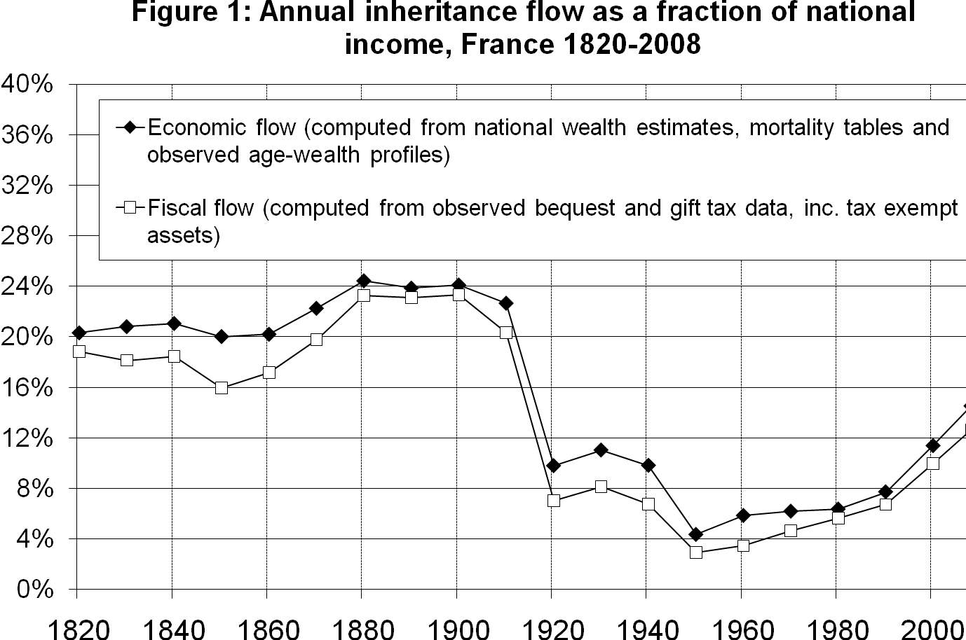
Table 2: Inheritance in Paris, 1872-1937 - Summary Statistics
 | N. decedents (20-yr +) | N. decedents with estate>0 | % decedents with estate>0 | Average estate (estate>0) | Average estate (all decedents)
 |  |  |  | (current francs)
1872 | 24,280 | 6,918 | 28% | 85,925 | 24,481
1912 | 36,520 | 10,217 | 28% | 133,547 | 37,362
1922 | 33,300 | 10,791 | 32% | 166,265 | 53,877
1927 | 35,842 | 11,204 | 31% | 256,435 | 80,160
1932 | 31,725 | 12,017 | 38% | 272,377 | 103,176
1937 | 30,274 | 12,790 | 42% | 219,343 | 92,666

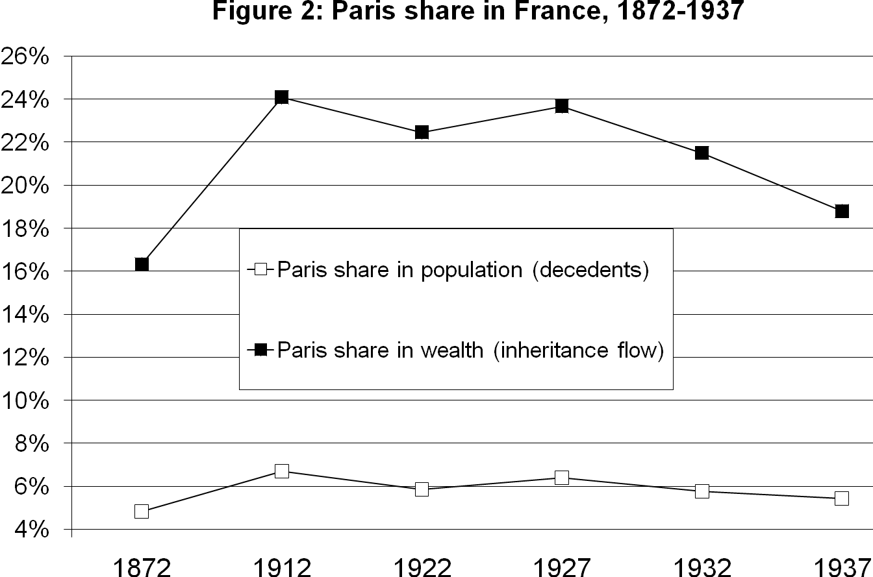
Table 3: Average estate vs price indexes in Paris 1872-1937
 | Average estate (estate>0) | Average estate (all deced.) | Consumer price index | Asset price index | Average estate (estate>0) | Average estate (all deced.)
 | (current francs) |  |  |  | (relative to asset price index)
1872 | 64 | 66 | 97 | 100 | 64 | 66
1912 | 100 | 100 | 100 | 100 | 100 | 100
1922 | 124 | 144 | 312 | 203 | 61 | 71
1927 | 192 | 215 | 574 | 273 | 70 | 79
1932 | 204 | 276 | 537 | 229 | 89 | 121
1937 | 164 | 248 | 616 | 242 | 68 | 102

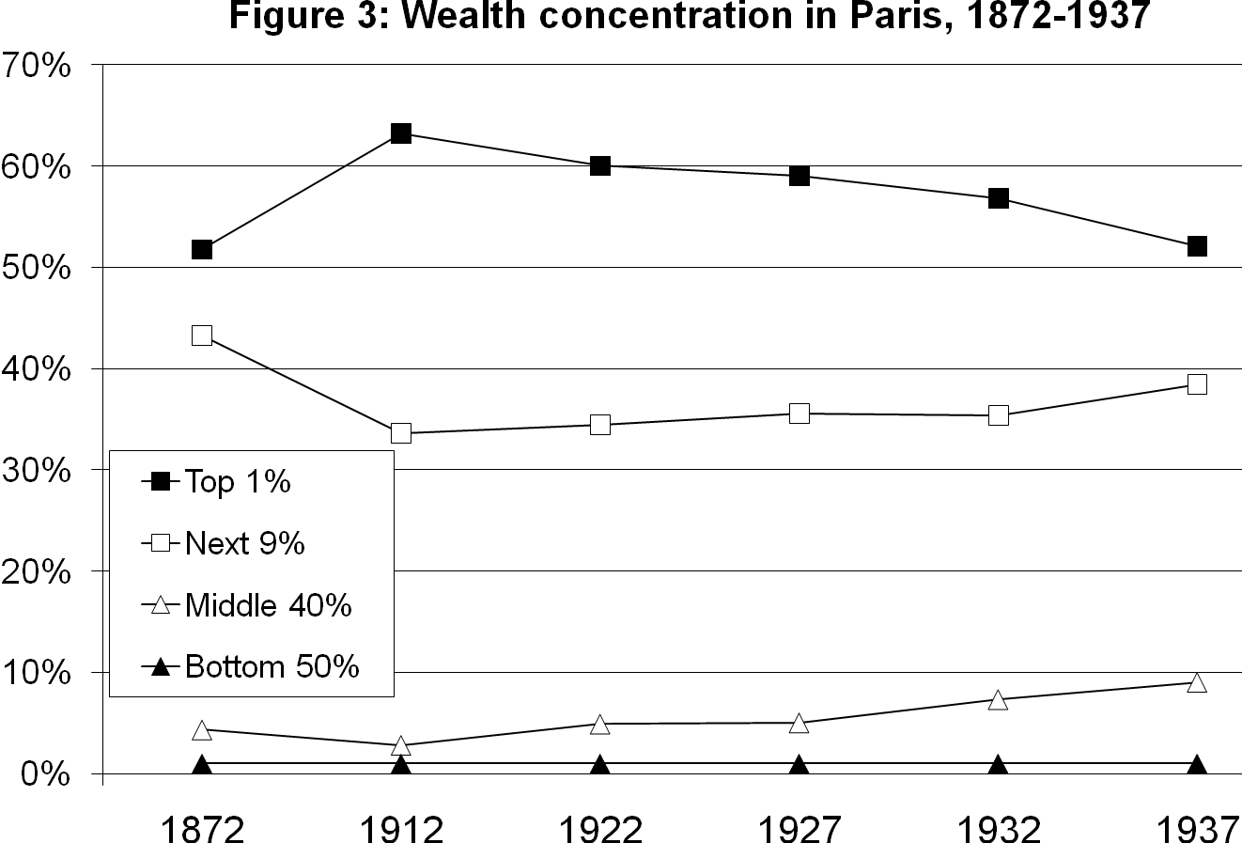
Table 4: Asset composition in Paris 1872-1937
 |  | Financial assets
(% gross assets) | Real estate assets | Total | inc. Equity | inc. Private bonds | inc. Govt bonds | inc. Other, cash,.. | Total foreign financial assets | Movables
1872 | 34% | 64% | 17% | 21% | 15% | 10% | 7% | 3%
1912 | 36% | 62% | 20% | 18% | 14% | 9% | 20% | 3%
1922 | 27% | 69% | 25% | 13% | 19% | 11% | 15% | 4%
1927 | 23% | 71% | 37% | 10% | 13% | 11% | 20% | 6%
1932 | 27% | 66% | 30% | 11% | 14% | 11% | 11% | 7%
1937 | 25% | 69% | 35% | 10% | 11% | 12% | 22% | 7%
Note: Out-of-Paris real estate assets are missing in 1872; in 1912-1937, they make about 1/3 of real estate assets. Total financial assets are drawn from the previous four columns.

Table 5: Community asset composition in Paris 1872-1937
 |  | Financial assets
(% gross assets) | Real estate assets | Financial assets | inc. Equity | inc. Private bonds | inc. Govt bonds | inc. Other, cash,.. | Total foreign financial assets | Movables
1872 | 34% | 63% | 20% | 20% | 11% | 12% | 5% | 3%
1912 | 29% | 68% | 27% | 17% | 14% | 11% | 21% | 3%
1922 | 17% | 78% | 30% | 14% | 22% | 12% | 13% | 5%
1927 | 12% | 81% | 46% | 10% | 13% | 12% | 24% | 7%
1932 | 16% | 77% | 35% | 12% | 15% | 15% | 11% | 8%
1937 | 15% | 76% | 42% | 11% | 11% | 12% | 20% | 9%
Note: Out-of-Paris real estate assets are missing in 1872; in 1912-1937, they make about 1/3 of real estate assets. Total financial assets are drawn from the previous four columns.

Table 6: Inherited asset composition in Paris 1872-1937
 |  | Financial assets
(% gross assets) | Real estate assets | Financial assets | inc. Equity | inc. Private bonds | inc. Govt bonds | inc. Other, cash,.. | Total foreign financial assets | Movables
1872 | 43% | 56% | 14% | 18% | 16% | 8% | 8% | 1%
1912 | 45% | 54% | 17% | 16% | 10% | 9% | 11% | 1%
1922 | 33% | 63% | 24% | 11% | 11% | 17% | 11% | 4%
1927 | 32% | 63% | 34% | 8% | 9% | 13% | 15% | 4%
1932 | 39% | 57% | 29% | 8% | 11% | 8% | 12% | 3%
1937 | 43% | 53% | 28% | 9% | 8% | 8% | 14% | 4%
Note: Out-of-Paris real estate assets are missing in 1872; in 1912-1937, they make about 1/3 of real estate assets. Total financial assets are drawn from the previous four columns.

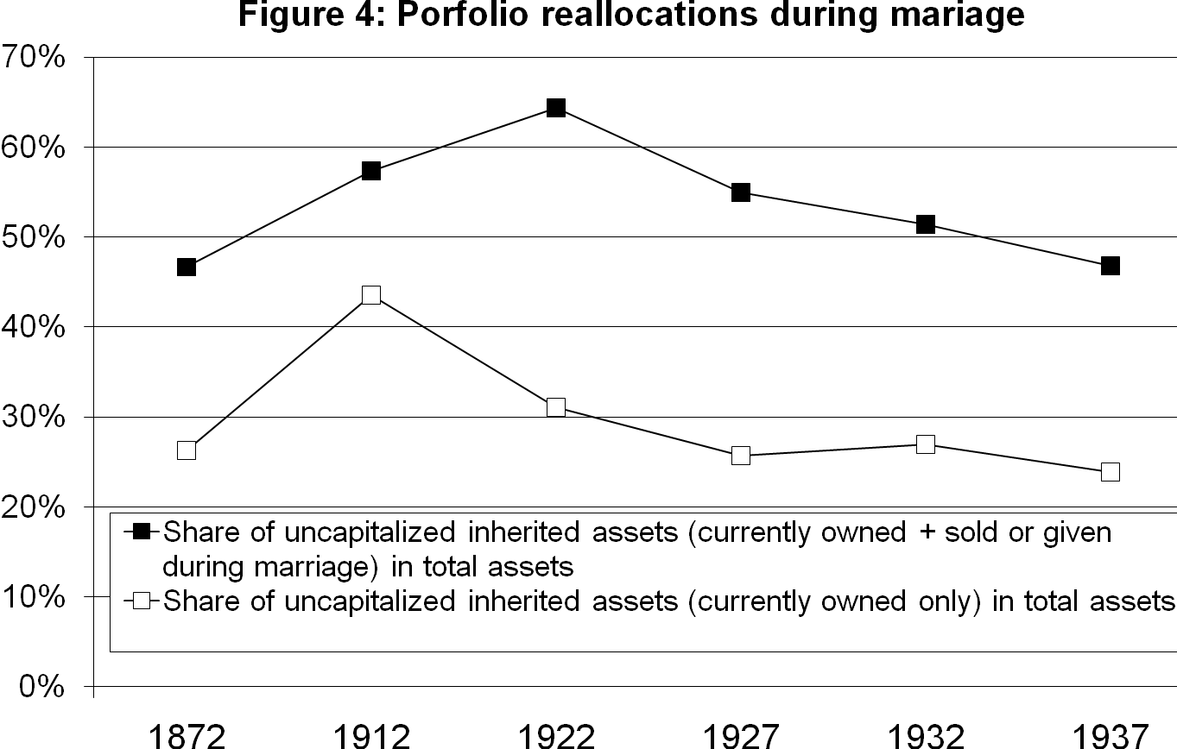
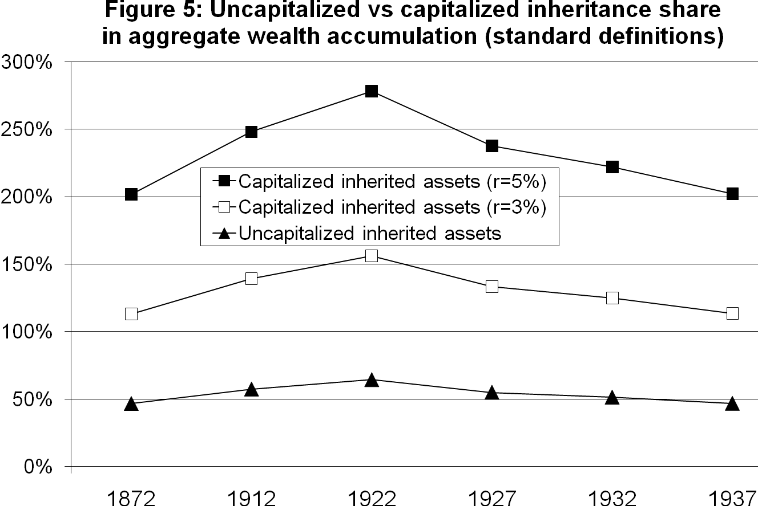
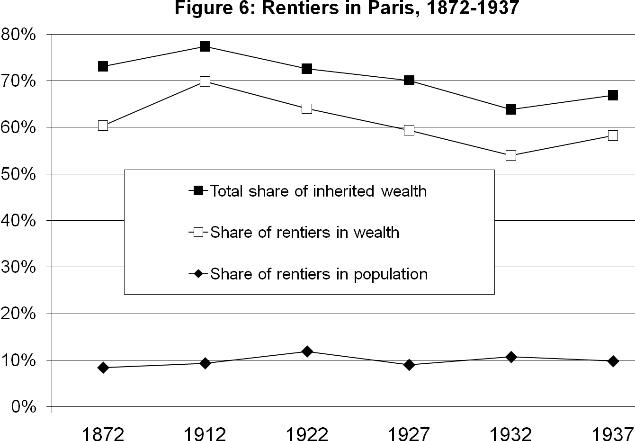
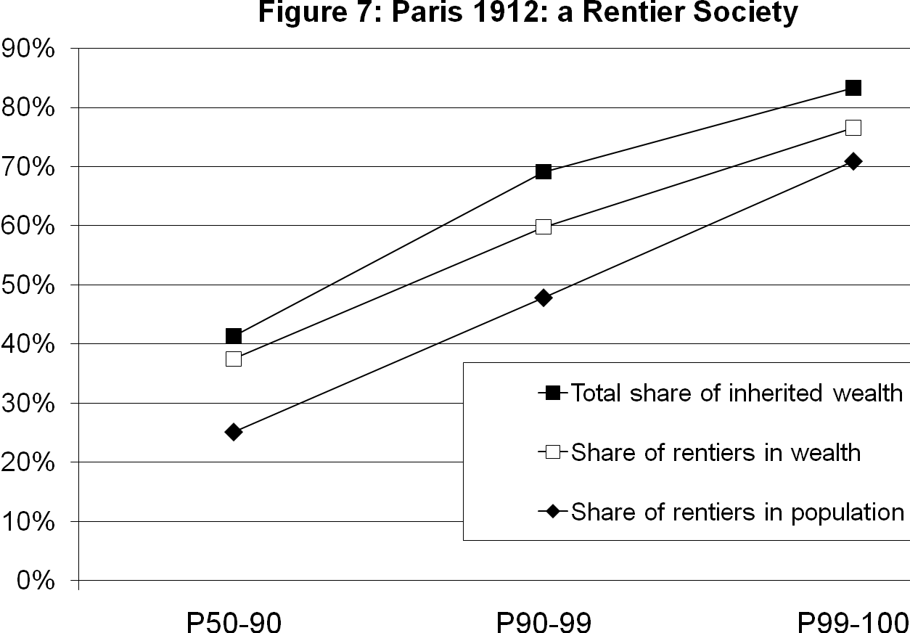
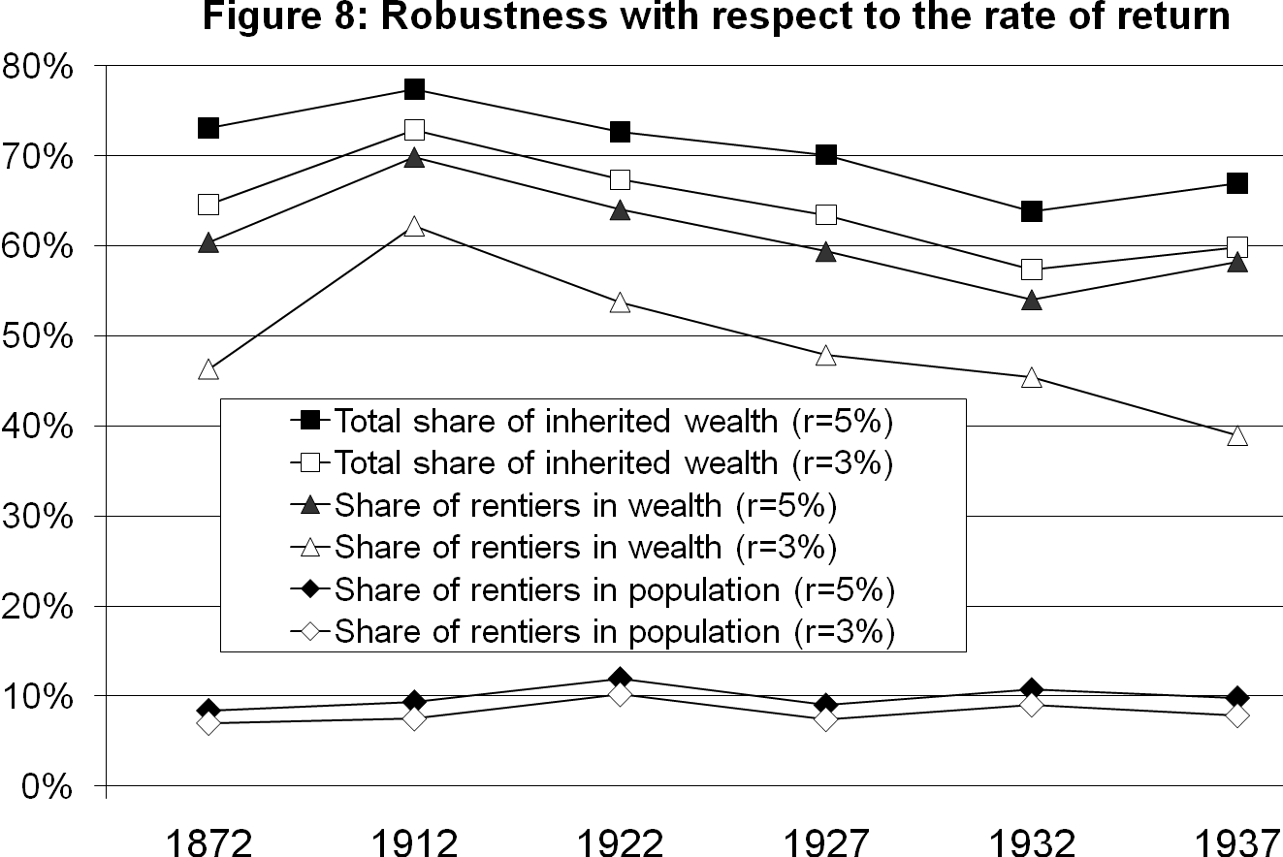

We simply took the raw wealth shares by wealth fractiles from the 2007 SCF reported by Kennickell (2009, Table 4). Kennickell later compares the top wealth levels reported in the SCF and in other data sources (such as Forbes 500 rankings), and finds that the SCF understates very top wealth shares.
In today’s France, per adult national income is about 35,000€ and per adult private wealth is about 200,000€. See e.g. Piketty (2010). Per adult averages are similar in the U.S. and other rich countries.
It is worth noting that the mainstream economists of the time described France as a place with a relatively egalitarian wealth distribution (thanks to the 1789 revolution, and as opposed to aristocratic Britain), and concluded from this “observation” that the introduction of progressive estate taxation was unnecessary in France (but might well be justified in Britain). See e.g. Leroy-Beaulieu (1881). Modern evidence suggests that wealth concentration at that time was actually almost as large in republican France as in aristocratic Britain (with a top 1% wealth share of 50%-55% in France, vs 60%-65% in Britain, i.e. as much as in Paris). We plan to further investigate this issue in future research.
See Piketty, Postel-Vinay and Rosenthal (2006). In this paper, we concentrated upon the long run evolution of cross-sectional wealth concentration in France. The novelty of the present paper is that by making use of the matrimonial property regime data we are now able to relate decedents wealth to the bequests and gifts received by the decedents during their entire lifetime; see section 4 below for more details on why French estate tax registers allow us to do so.
Wealth is currently somewhat more concentrated in the U.S. than in other developed countries. E.g. in France the top 10% wealth appears to be closer to 60% than to 70%, and the bottom 50% wealth share is closer to 5% than to 2%. But the figures are roughly comparable, as a first approximation.
One important implicit assumption in these definitions and computations is that the rate of return r_{t} is the same for all assets and all individuals (and is the same as the borrowing rate). In practice rates of return r_{ti} vary enormously across assets and individuals. To the extent that on average r_{t}(w) tends to rise with wealth w (e.g. because of fixed costs), and that the borrowing rate is higher than the lending rate, this would most certainly tend to amplify the inequality in lifetime resources between inheritors and savers. Our assumption of a common r_{t} is a natural starting point, and is probably justified as a first approximation; but this is an issue that should be addressed in future research
In the U.S., wealth concentration is actually somewhat larger: the top 10% share alone is equal to 72% (see Table 1 above). On the other hand some top decile individuals are savers, not rentiers.
b_{t}⁰=ρ_{t}b_{tr}⁰+(1-ρ_{t})b_{ts}⁰=88,00€, and 88,000/244,000=36%.
b_{t}*=ρ_{t}b_{tr}*+(1-ρ_{t})b_{ts}*=292,00€, and 292,000/244,000=120%.
In effect, Modigliani defined savings as labor income plus capital income minus consumption (and then defines life cyle wealth as the cumulated value of past savings), while Kotlikoff-Summers defined savings as labor income minus consumption. Given that the capital share is typically larger than the savings rate, this of course makes a big difference. See Piketty (2010).
400,000€/900,000€ = 44%.
See Piketty (2010). In the original K&S-M controversy, Kotlikoff and Summers found an inheritance share of “only” 80% for the U.S. (i.e. somewhat less than 100%), which was already quite large, given that Modigliani was claiming that the right number was 20%, in spite of the fact that both were using the same data. Both sides were using US data of the 1960s-1970s, a time at which aggregate inheritance flows were unusually low. Also, they were not fully taking into account inter vivos gifts, which are hard to measure in the U.S. given the imperfections of U.S. estate tax data. They were also deducting from the aggregate inheritance flow the share going to surviving spouses (typically 10%-15%), which we do not feel is justified, especially in a world with frequent divorce and remarriage.
Here we ignore a number of legal and empirical complications, in particular due to asset portfolio reallocations during marriage and reimbursements between spouses, and due to inter vivos gifts and dowries. In section 3 we provide more details on the French matrimonial property regime and the way we use the data that goes with it in order to compute w_{ti} and b_{ti}*.
These results extend the steady-state formulas derived by Piketty (2009) in an aggregate setting.
The French Revolution may not have created a perfect meritocracy; but at least it created a data source to study wealth and inheritance. The United Kingdom did not see a universal estate tax before 1894, and the United States waited until 1916. Even after these dates, only a small minority of the population was required to fill estate tax returns in these two countries, so the data is much less rich.
See Piketty, Postel-Vinay and Rosenthal (2006).
Strictly speaking, separate property assets also include assets that were acquired (rather than inherited) by the husband or the wife prior to the marriage. Within the set of assets owned before marriage, we can’t distinguish between acquired and inherited assets. However because most people married at a relatively early age and rarely divorced at that time, the non-inherited fraction of separate property assets is bound to be very small. In order to test for this assumption, we re-did the computations with the sub-samples of decedents who married early and late (we observe the date of marriage in the tax registers), and found no significant difference in the results.
In the registers, we actually observe the address for each piece of real estate property, the company name and corresponding stake for each equity or bond asset, etc. We reclassified these assets into broad categories. See section 5 below, and Appendix B for detailed results. Unlike probates, however, we do not observe the details of household goods just an aggregate value.
Prior to World War 1 this was almost irrelevant, since there was virtually no inflation. During and after WW1 this becomes a significant issue, and we will make the necessary adjustments (see below).
So as to simplify exposition, we actually note a_{ti}^{R} and a_{tj}^{R} the net reimbursement values owed by the community to each spouse, i.e. the net difference between reimbursement owed by the community and reimbursements owed to community. The latter are usually much smaller than the former, so net reimbursement values are generally positive. Reimbursements owed to the community correspond to situations when some community income or asset was used during the marriage in order to raise the value of a separate asset (say, to repair the roof of a countryside house, or to repay a business debt or invest in a business, in case these are separate assets). See Appendix B (Table B17) for full details. Note that reimbursements owed by the community used to be called “contributions” (“reprises en deniers”, as opposed to the separate assets a_{ti} and a_{tj} used which were never sold, and which are sometime referred to as “reprises en nature”). Both types of reimbursements now tend to be called “reimbursements” (“recompenses”). The exact wording used by the Civil Code has changed slightly over time, but the concepts and rules have remained the same since 1804.
In most cases, no will is written, and the following default rules apply. Since the 2001 reform of the Civil Code (the main purpose of which was to better protect surviving spouses), the surviving spouse has the choice between the usufruct (“usufruit”) of 100% of w_{it} or the full property of 25% of w_{it}; the rest is divided equally between the decedent’s children. But prior to the 2001 reform, in the absence of will, the surviving spouse was only getting the usufruct of 25% of w_{it}, and the rest was divided equally between the decedent’s children (this rule was in place since 1804). Note also that children have always been strongly protected by the Civil Code: even with a will, the children share in w_{it} cannot be less than 50% with one child, 66% with two children, and 75% with three children or more; in addition, equal splitting must prevail within this so-called “reserve héréditaire” (only the remaining part can be allocated freely by will; this is the so-called “quotité disponible”). This basic rule has been unchanged since 1804. The 2001 reform simply created an extra rule to protect surviving spouses, which now must get at least 25% of w_{it} in the absence of children. Before 2001 decedents could choose by will to leave 0% of w_{it} to the surviving spouse, even in the absence of children. With children, it is still possible today to leave 0% of w_{it} to the surviving spouse if the decedent wishes to do so. The complete rules are fairly complex (e.g. it is only the 1970s that children born outside of marriage obtained the same rights as legitimate children); this is just a quick summary.
This is not saying that the Civil Code at large has always been gender neutral. For instance, during most of the 19th century, married wives had limited legal rights to sell and purchase community assets (or contract community debts) on their own, i.e. without the husband’s signature. Under some marriage contracts, these limited rights also applied to their separate property assets. Some asymmetries persisted well into the 20th century (e.g. married wives could not open bank accounts without the husband’s signature until the 1970s). However the important point here is that in France these legal asymmetries between husbands and wives in control rights over assets during marriage did not entail asymmetries in formal property rights and sharing rules at the time of death or divorce.
The only exception is capital gains. In effect, the French Civil Code does not treat capital gains as ordinary capital income and makes a sharp distinction between the first sale of inherited assets (in which case capital gains fall into separate property) and further portfolio reallocations (in which case capital gains fall into community property).
See e.g. « World Map of Matrimonial Property Regimes », Notarius International 1-2 (2005).
See Appendix B, Table B15. We do not observe full marriage contract details for all married decedents. However the marriage contract information that we collected in the tax registers for a subsample of decedents shows that “universal community” is almost never used, and that “separation of property” is the only significant alternative arrangement. Therefore we identify all married decedents with positive community assets as being married under the “community of acquisitions” regime, and we find that this fraction is approximately stable around 85%-90% for all years and all wealth fractiles, except at the level of the top 0,1%, where it goes down to about 50%-60%. In effect we are excluding married decedents who were married under the default regime but who did not accumulate any community asset. Also it is likely that married couples opting for the “separation of property” regime tend to have above average inherited assets (for given total assets). Therefore by focusing upon married decedents with positive community assets we are probably under-estimating somewhat the true inheritors shares in population and wealth.
About 15% of widow decedents have assets reported as community assets in their estate tax return (as compared to 85%-90% of married decedents). A small number of single and divorced decedents (less than 5%) also have assets reported as community assets. See Appendix B, Table B15. We did not attempt to use the community vs separate asset information available for non-married decedents.
The fact that we observe the wife’s reimbursements a_{tj}^{R} at the husband’s death does however give us some (imperfect but interesting) information about assortative mating. See section 5 below.
The same procedure is applied symmetrically to deceasing married men and women.
See Piketty (2010, Appendix C, Table C15).
If year-t decedents and their parents died at exactly the same age, then t-t_{i} would be exactly equal to H_{i} (where H_{i} is the age of the decedent’s parents when the decedent was born), i.e. it would be equal to a distribution centred around H=30 with standard deviation of about 5.5-6.5. However in general children and their parents do not die at the same age, which creates extra variations. In order to take this into account we assume that t-t_{i} is uniformly distributed over [H-10;H+10]. For a more complete attempt to estimate the age distribution of inheritance receipts (taking explicitly into account the fact that about 70% of inheritance flows go to children, 10% go to surviving spouses, and 20% go to other heirs – mostly nieces/nephews and brothers/sisters), see Piketty (2010, Appendix C).
See Appendix B, Tables B20-B21 for the detailed results obtained under our benchmark assumptions and under the assumption of fixed gaps t_{i}*-t_{Mi}=5 and t-t_{i}=30 (i.e. no idiosyncratic shock). As one can see, the results for the shares of inherited wealth in total wealth are extremely close under both sets of assumptions (inherited shares are somewhat larger under our benchmark case, because of the convexity of the capitalization effect).
More details on the asset price indexes that we use are given in Appendix A. We return to this issue when we present the results in section 5 below.
These various assumptions are discussed in section 5 below.
See Bulletin de statistique et de legislation compare (BSLC), 1899.
Note that in a small number of cases there are dowries which were promised but not given to the children (either because the marriage contract planned family affairs in this way, or whatever other reason). However this appears to be a very small fraction of cases, so we do not make any special correction for this. In any case, note that since most dowries were made relatively shortly before death (see above), this dowry capitalisation effect is bound to be relatively small.
Note that our individual wealth concept w_{ti} (as defined by equation (4.16)) differs from the legal concept of individual estate e_{ti} (as defined by equation (4.9)) for two different reasons: first because we upgrade reimbursements and dowries in order to take into account asset price inflation (this plays essentially no prior before World War 1); next because of the dowries capitalisation effect (this effect is quantitatively limited but is conceptually present throughout the 1872-1937 period).
For background data on the national income and wealth accounts of France and Paris at that time, see Appendix A.
See Piketty, Postel-Vinay and Rosenthal (2006).
Note that this 20%-30% figure is roughly equal to the share of aggregate assets that suffered from physical destruction and expropriation (e.g. Russian bonds) during World War 1 in France. According to the best available national accounts estimates, destruction and expropriation accounts for the about one third of the aggregate fall of the French private wealth-national income ratio between 1913 and the 1920s, while the other two thirds come from the fall in the relative price of assets (itself being due to a number of factors including of course nominal rigidities in the price of certain assets, rent control policies, higher taxes on profits and top incomes, political instability and others). See Piketty (2010).
Checking accounts, cash, current income including pensions, etc. For detailed results with more asset categories, see Appendix B.
See Appendix B, Table B11.
Note that the fraction of inherited assets sold or given during marriage is about 45% in 1872 and 50% in 1922-1937, but appears to be significantly lower in 1912 (about 25%). This could reflect the fact that wealth holders are particularly prosperous in 1912 and faced less of need to sell some of their souse’s assets. Conversely the very fraction observed in the interwar (and particularly in the 1920s) could reflect the impact of shocks. We return to this issue below.
For the all of France, aggregate inheritance flow series and observed average rates of return imply aggregate capitalized bequest shares φ_{t}^{KS} around 250%-300% during the 1870s-1930s period (down to 100%-150% in the 1950s-1970s); aggregate uncapitalized bequest shares φ_{t}^{M} are around 70%-80% prior to World War 1, down to about 50%-60% in the 1920s-1930s, and to less than 40% in the 1950s-1960s. See Piketty (2010). For Paris, our micro data shows that uncapitalized bequest shares φ_{t}^{M} have been relatively stable around 50%-60% during the 1870s-1930s. It could be however our methodology leads us to under-estimate somewhat the share of inherited assets (both because we neglect married decedents under the “separation of property” regime and married decedents with zero community assets; and because we do not include all inter vivos gifts).
With the possible exception of the 1920s, where wife’s inherited assets appear to be sold and given more often than husband’s inherited assets. However this is marginally significant, and holds only in married couples where the husband dies first (when the wife dies first, symmetry prevails again). For detailed results, see Appendix B, Table B16.
See section 4 above.
The fact that the symmetry in asset sales holds in all wealth fractiles, and that we also observe very high individual-level correlation between husbands’ and wives’ asset sales, certainly suggests a very high degree of assortative mating. But the individual-level correlation between sales is bound to be a lower bound estimate of assortative mating, since there are all sorts of idiosyncratic shocks explaining individual level propensity to sell or give inherited assets. We plan to further explore these interesting issues in the future.
It was acutally as large as 30%-35% in 1872-1922, and then declined to about 25%-30% in 1927-1937. But because the fraction of wealth holders in total population increased in the interwar, the fraction of rentiers in total population was pretty stable around 10% throughout the 1872-1937 period, with no trend. See Appendix B, Table B18.
See Appendix B, Table B18.
The profiles obtained for other years have a similar shape. See Appendix B, Table B18.
See Appendix B, Table B18. Note however that our individual level definitions rely on the assumption of perfect assortative mating (see section 3 above). It could well be a substantial fraction of this group started off with very little wealth, but married with someone with large inherited wealth. We plan to further investigate this in future research.
In particular, during the 1872-1912 period, and more generally during the entire 1820-1913 period, the estimated capital share α_{t} was about 35%-40% of national income (or even higher), while the aggregate private wealth-national income ratio β_{t} was about 600%-700%, i.e. the average rate of return r_{t}=α_{t}/β_{t} was about 5%-6% (or even higher). During the chaotic 1912-1937 period, rates of return vary of course a lot across assets and over sub-periods (even more than in the previous period). But because asset values were low, average rates of returns were actually larger than 5%. See Appendix A for basic French national income and wealth accounts data over this period. See Piketty (2010) for detailed data and analysis of these issues.
See Hoffman, Postel-Vinay, and Rosenthal (2007).

